

|  |
| --- |
| Capstone Project Document |

**BOOKAHOLIC SOCIAL NETWORK**

Software Requirement Specifications

|  |  |  |
| --- | --- | --- |
| **Bookaholic Social Network** | | |
| **Group Members** | Phạm Thị Huyền | SE03416 |
| Thái Thị Cẩm Vân | SE03409 |
| Vũ Hải Đăng | SE03380 |
| Nguyễn Thị Hải Yến | SE03171 |
| Chu Minh Hải | SE03143 |
| **Supervisor** | Mr. Nguyễn Văn Sang | |
| **Project code** | BSN | |

**- Hanoi, 09/2016 -**

# SIGNATURE PAGE

|  |  |  |
| --- | --- | --- |
| AUTHOR: | Phạm Thị Huyền  Project manager | 09/16/2016 |
| REVIEWERS: | ----  Team member | --/--/2016 |
| APPROVAL: | Nguyễn Văn Sang  Supervisor | --/--/2016 |

**Record of change**

*A - Added M - Modified D – Deleted

|  |  |  |  |  |  |
| --- | --- | --- | --- | --- | --- |
| Effective Date | Changed Item | A,M,D | Change Description | Reason for Change | Rev. Number |
| 09/16/2016 | Create | A | Create | First version | 1.0 |
| 10/21/2016 | Update | M | Add new functions | Add new functions of phase 2 | 1.1 |
| 11/25/2016 | Update | M | Add new functions | Add new functions of phase 3 | 1.2 |

Table of Contents

SIGNATURE PAGE 2

1. INTRODUCTION 3

1.1. Purpose 3

1.2. Definitions and Acronyms 4

1.3. System Purpose 4

2. OVERALL DESCRIPTION 4

2.1. System overview 4

2.2. Use Case Diagram 4

2.3. Product Features 5

2.3.1. User Characteristics 5

2.3.2. User Documentation 5

2.3.3. Assumption 5

2.4. Entity Relation Model 5

2.4.1. Entity-Relationship Diagram 5

2.4.2. Entity Detail 5

3. FUNCTIONAL SPECIFICATION 5

3.1. Business Rules 5

3.2. Use Cases 5

4. NON-FUNCTIONAL SPECIFICATION 5

4.1. Reliability 5

4.2. Performance Requirements 5

4.2.1. Availability 5

4.2.2. Response time 5

4.2.3. Maintainability 5

4.2.4. Usability 5

4.2.5. Security Requirements 5

4.2.6. Hardware/Software Requirements 5

# INTRODUCTION

## **Purpose**

This document is created as the introduction for project Bookaholic Social Network – our Capstone Project at FPT University. In this document, we provide the describing of general requirement and non-functional requirements. These requirements will assure that the system will correctly and reliably perform its intended functionality. This specification will provide general, as well as specific requirements to be used in the design, testing and validation of the system. It is intended for both stakeholders and the project team of the system.

## **Definitions and Acronyms**

|  |  |  |
| --- | --- | --- |
| **Acronym** | **Definition** | **Note** |
| BSN | Bookaholic Social Network |  |
| SRS | Software Requirements Specifications |  |
| UC | Use Case |  |

Table ‑: Definition and Acronyms

## **System purpose**

Nowadays, social network plays an essential role in our lives. Vietnam is the country that has the big Internet user growth and the trend of communication through social network is expanding rapidly, people shares and discuses about everything through social network. However, there is not any social network that is for only Vietnamese people who love reading books. To solve this problem, we create a website where people who loves book can share and discus with others about their favorite books or authors. We believe this project will strengthen Vietnam’s reading culture.

# OVERALL DESCRIPTION

## **System overview**

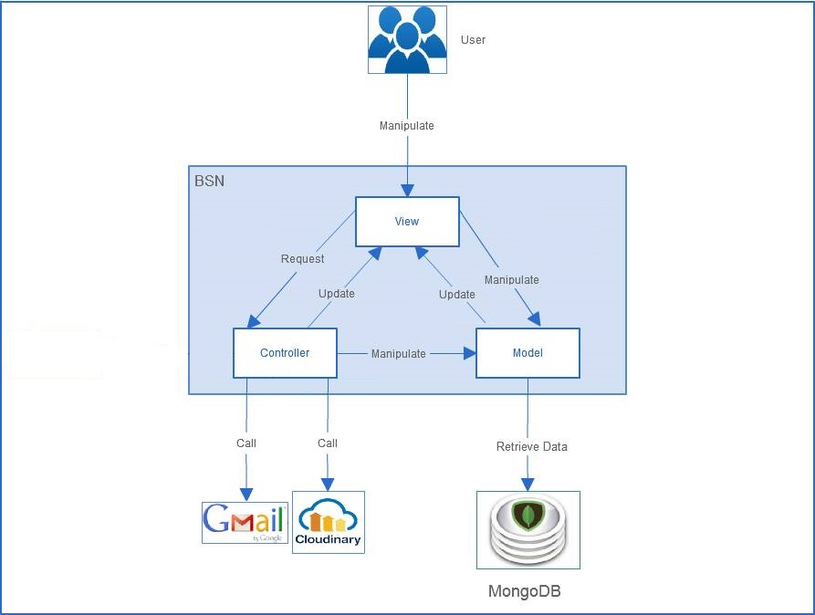

Figure ‑: BSN System Overview

## **Product Features**

|  |  |  |  |
| --- | --- | --- | --- |
| **Use Case No.** | **Group of functions** | **Functions** | **Glossary** |
| **GUEST MODULE** | | | |
| **UC001** | Register | Register for a normal account | Register for a normal account (reader) |
| **UC002** | Register for an author account | Register for an author account: User must upload an image of their identity card and wait for approve from admin of website. |
| **READER/AUTHOR MODULE** | | | |
| **UC003** | Account | Login | Login by registered account |
| **UC004** | Logout | Logout |
| **UC005** | Edit personal information | Edit personal information includes name, email, address, date of birth. |
| **UC006** | Edit avatar and cover photo | Edit avatar and cover photo |
| **UC007** | Reset password | Reset password by confirm an auto email. |
| **UC008** | Post | Create a post | Create a post to introduce about book(s). User has to tag book(s) as the topic of that post. |
| **UC009** | Edit a post | Edit caption and book tags of a created post. |
| **UC010** | Delete a post | Delete posts |
| **UC011** | Like a post | Like posts |
| **UC012** | Unlike a post | Unlike posts |
| **UC013** | Comment on a post | Comment on a post |
| **UC014** | Delete a comment | Delete comments |
| **UC015** | Interaction | Follow user account | Follow other account to get their new post on new-feed. |
| **UC016** | Send message | Send message to other accounts. |
| **UC017** | Report user account | Report other accounts. |
| **UC018** | Send join-group request | Send join-group request. After that, users have to wait admin of that group to add them as members. |
| **UC019** | Leave a group | Members can leave a group themselves. |
| **UC020** | Report a group | Report groups. |
| **UC021** | Get Notification | Users get notification when: + Other users like their post + Other users comment on their post + Other users follow their account |
| **UC022** | Group | Create a group | To create a group, users have to tag a book/author as the topic of that group. |
| **UC023** | Edit group information | Edit group profile |
| **UC024** | Edit group's avatar/cover photo |  |
| **UC025** | Add new members | Add new members by enter account name. |
| **UC026** | Accept join-group request | Users can send a request to group and admin have right to accept them as members or not. |
| **UC027** | Set group's admin | Set other members in group as admins. |
| **UC028** | Remove a member | Admins of a group van remove other members from their group. |
| **UC029** | Create a group post | Create group posts: Members do not need to tag books or authors. |
| **UC030** | Like a group post |  |
| **UC031** | Edit a group post | Edit group posts. |
| **UC032** | Delete a group post | Delete group posts. |
| **UC033** | Comment on a group post |  |
| **UC034** | Delete comment on a group post |  |
| **UC035** | Book | Rate a book | Rate a book: the highest score is 5 stars. |
| **UC036** | Comment on a book | Comment about book in its own details page |
| **UC037** | View a book's details | View details about a book: image, description, rating and comments of readers about that book. |
| **UC038** | Search book/author/other account/group | Search book/author/other account/group |
| **UC039** | View suggested books/authors | BSN system suggests books/authors base on the trend of reading: + Book: by access times + Author: by number of followers |
| **ADMIN MODULE** | | | |
| **UC040** | User Accounts Management | Search user | Search user |
| **UC041** | Ban user | If an account is reported, admin of page has right to ban that account of decline the reporting request. |
| **UC042** | Unban user | Unban user |
| **UC043** | Decline request about reporting an account | If an account is reported, admin of page has right to ban that account of decline the reporting request. |
| **UC044** | Accept request about creating author account |  |
| **UC045** | Decline request about creating author account | Accept/decline request about creating author account from guests. |
| **UC046** | Groups Management | Band a group | When a group is reported, admin of page can band it. |
| **UC047** | Unban a group | Unban a group |
| **UC048** | Decline request about reporting a group |  |
| **UC049** | Books Management | Add a new book | Add new books. |
| **UC050** | Add a new Category | Add new Categories. |
| **UC051** | Add an author | Add Authors |
| **UC052** | Edit book's information | Edit book's information |
| **UC053** | Accept add-book request |  |
| **UC054** | Decline add-book request | Approve/decline requests about adding a book |
| **UC055** | Sliders Management | Add a new slider | Add new sliders to introduce about website. |
| **UC056** | Delete a slider | Delete sliders. |
| **UC057** | Active/de-active a slider | Active/de-active slides. |
| **UC058** | Show a slider | Display sliders on the login page. |
| **UC059** | Publishers Management | Add a new publisher | Add new publishers |
| **UC060** | Edit publisher' information | Edit publishers' information |
| **UC061** | Delete a publisher | Delete publisher |
| **UC062** | Statistics | View user statistic | View statistic about users: + number of old accounts + number of new accounts |
| View author statistic | View statistic about authors: + number of old accounts + number of new accounts + authors with largest number of followers |
| View group statistic | View statistic about groups: + number of old groups + number of new groups |
| View book statistic | View statistic about books: + number of old books + number of new books + the book in trend: base on number of access time |

### **User Characteristics**

BSN website aim towards to anyone loves books and looking for a website to share their thought and make friends with other readers. Below are main actors that our system supports:

* **Guest:** Users who have not created an account, they can use functions such as: register for a normal account or register for an author account.
* **Readers & Authors:** Users who have account on system, they can use almost functions of website. For example: searching, posting, rating, connect to friends, etc.
* **Administrators:** They have an administrator control panel to manage all configurations of system

### **User Documentation**

|  |  |
| --- | --- |
| Name | Description |
| User guideline | Provide detailed explanation about the system, screens and guide users how to use all features of BSN system. |
| Installation guide |  |

### **Assumption**

* Receive the guidance and good support from teacher.
* No one of members in group gets sick in the software development process.
* In the development process, no device gets fail.
* Every report meets the deadline.
* Team members do not conflict in the work process.

## **Entity Relation Model**

### **Entity-Relationship Diagram**

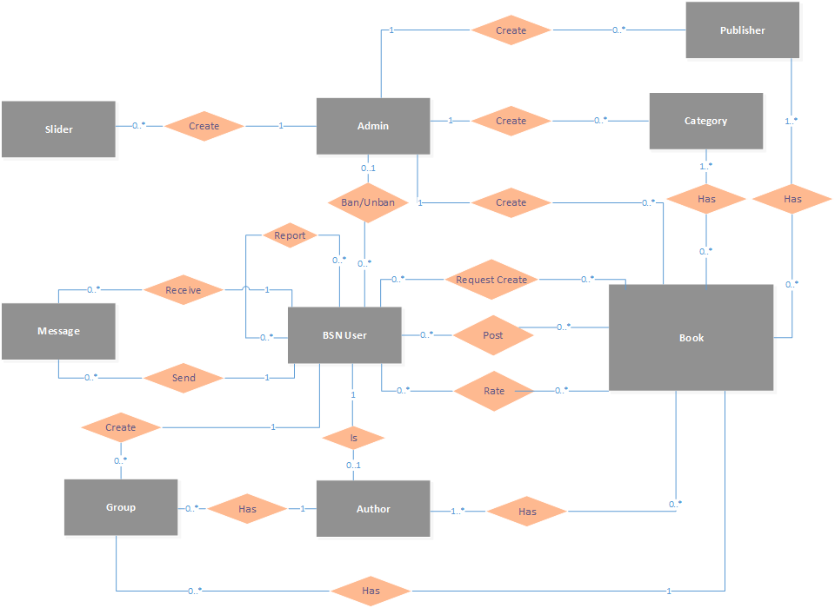

Figure ‑: Entity Relationship Diagram

### **Entity Detail**

#### 2.3.2.1 BSN User

|  |  |  |
| --- | --- | --- |
| No | Properties | Description |
| 1 | Name | User’s name |
| 2 | Email | User’s email |
| 3 | Password | User’s password |
| 4 | Role | User’s role (includes: reader, author, admin) |
| 5 | Gender | User’s gender |
| 6 | Avatar photo | User’s avatar photo |
| 7 | Cover photo | User’s cover photo |
| 8 | List followings | List users that this user is following |
| 9 | List followers | List users following this user |
| 10 | List messages | List messages of this user |

#### 2.3.2.2 Admin

|  |  |  |
| --- | --- | --- |
| No | Properties | Description |
| 1 | Name | Admin’s name |
| 2 | Email | Admins email |
| 3 | Password | Admin’s password |

#### 2.3.2.3 Author

|  |  |  |
| --- | --- | --- |
| No | Properties | Description |
| 1 | Name | Author’s name |
| 2 | Email | Author’s email |
| 3 | Password | Author’s password |
| 4 | Gender | Author’s gender |
| 5 | Avatar photo | Author’s avatar photo |
| 6 | Cover photo | Author’s cover photo |
| 7 | Address | Author’s address |
| 8 | SSN Image | Author’s SSB image |
| 9 | List followings | List users that this author is following |
| 10 | List followers | List users following this user |
| 11 | List messages | List messages of this user |
| 12 | List books | List books of this user |

#### 2.3.2.4 Book

|  |  |  |
| --- | --- | --- |
| No | Properties | Description |
| 1 | Name | Book’s name |
| 2 | Image | Book’s image |
| 3 | Release day | Book’s released day |
| 4 | Description | Book’s description |
| 5 | Rating point | Book’s sum of all rating points |
| 6 | Rating time | Book’s count number of rating time |
| 7 | List categories | List categories of this book |
| 8 | List publishers | List publishers of this books |
| 9 | List authors | List authors of this books |
| 10 | List comments | List comments of this books |

#### 2.3.2.5 Publisher

|  |  |  |
| --- | --- | --- |
| No | Properties | Description |
| 1 | Name | Publisher’s name |
| 2 | Address | Publisher’s address |
| 3 | Phone number | Publisher’s phone number |
| 4 | Image | Publisher’s image |

#### 2.3.2.6 Group

|  |  |  |
| --- | --- | --- |
| No | Properties | Description |
| 1 | Name | Group’s name |
| 2 | Status | Group’s status (locked or not) |
| 3 | Type | Group type (publish or private) |
| 4 | Created Date | Group’s created date |
| 5 | Tag | Group’s tag (book or author) |
| 6 | Description | Group’s description |
| 7 | Avatar photo | Group’s avatar photo |
| 8 | Cover photo | Group’s cover photo |
| 9 | List members | List members of this group |
| 10 | List requests | List requests to join this group |

#### 2.3.2.7 Message

|  |  |  |
| --- | --- | --- |
| No | Properties | Description |
| 1 | Time | Message’s sent time |
| 2 | Content | Message’s content |
| 3 | Status | Message’s status (delivered or not) |

#### 2.3.2.8 Slider

|  |  |  |
| --- | --- | --- |
| No | Properties | Description |
| 1 | Image | Slider’s image |
| 2 | Description | Slider’s description |
| 3 | Status | Slider’s Status (showed or not) |

#### 2.3.2.9 Category

|  |  |  |
| --- | --- | --- |
| No | Properties | Description |
|  | Name | Category’s name |

# FUNCTIONAL SPECIFICATION

## **Business Rules**

|  |  |
| --- | --- |
| No | Description |
|  |  |

## **Use Cases**

### 3.2.1 Guest Model

#### 3.2.1.1 Register

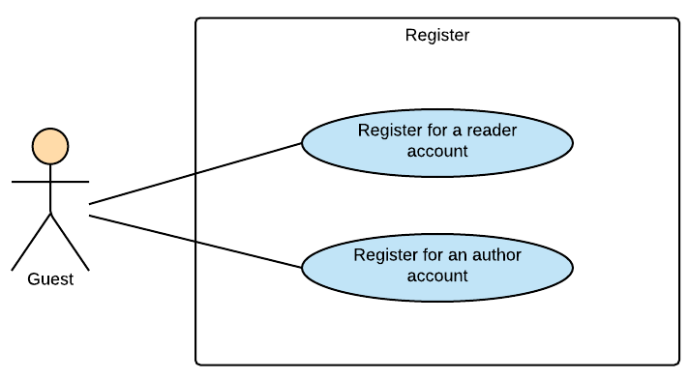

Figure ‑: Guest Module - Register

##### 3.2.1.1.1 UC001-Register for a normal account

###### 3.2.1.1.1 .1 Use Case Specification - Normal flow

|  |  |  |  |  |
| --- | --- | --- | --- | --- |
| **Use Case ID** | | UC001 | **Version** | 1.0 |
| **Use Case Name** | | Register for a normal account | | |
| **Created by:** | | HaiCM | **Date Created:** | 09/16/2016 |
| **Primary Actor** | | Guest | **Secondary Actor** | N/A |
| **Description:** | | This function allow guests to register for a normal account (reader account) | | |
| **Preconditions:** | | 1. Guest are viewing Login-register page  2. Enter information in register form | | |
| **Trigger:** | | Click on “Đăng ký” button on the website | | |
| **Post conditions:** | | Confirm mail has sent to guest’s email. | | |
| **Normal Flow** | | | | |
| **Step** | **Actor** | **Action** | | |
| 1 | User | Enter BSN website | | |
| 2 | BSN | Display Login-register page includes:   * Email textbox * Password textbox * Login button: “Đăng nhập” * Forgot password hyperlink: “Bạn quên?” * Account name textbox on register form * Email textbox on register form * Password textbox on register form * Author registers hyperlink: “Tác giả đăng ký”   Sign up button: “Đăng ký” | | |
| 3 | User | Enter information in register form on website | | |
| 4 | User | Click “Đăng ký” button | | |
| 5 | BSN | Send confirm email | | |
| 6 | User | Follow guide in confirm email | | |
| 7 | BSN | Confirm account | | |
| 8 | BSN | Redirects user to Login-register page | | |
| **Priority** | | High | | |
| **Frequency of Use:** | | High | | |
| **Business Rules:** | |  | | |
| **Other Information:** | | N/A | | |

###### 3.2.1.1.1 .2 Alternative Flows and Exceptions

|  |  |  |  |  |
| --- | --- | --- | --- | --- |
| **Alternative Flows:** | | | | |
| **AT1** | At step 4 in the main flows, if user click other hyperlinks or buttons | | | |
| **Step** | **Actor** | | **Action** | |
| 4.1 | BSN | | Redirects user to chosen hyperlink or button | |
|  | | | | |
| **Exceptions: N/A** | | | | |
| **EC1** | | At step 4, required fields are not entered | | |
| **Step** | | **Actor** | | **Action** |
| 4.1 | | BSN | | Display Login-register page with message: with ID MSG |
| 4.1 | | BSN | | Mark error fields |
|  | |  | |  |
| **EC2** | | At step 4, fields are entered with wrong type of data | | |
| **Step** | | **Actor** | | **Action** |
| 4.1 | | BSN | | Display Login-register page with message: with ID MSG |
| 4.2 | | BSN | | Mark error fields |

##### 3.2.1.1.2 UC002-Register for an author account

###### 3.2.1.1.2 .1 Use Case Specification - Normal flow

|  |  |  |  |  |
| --- | --- | --- | --- | --- |
| **Use Case ID** | | UC002 | **Version** | 1.0 |
| **Use Case Name** | | Register for an author account | | |
| **Created by:** | | HaiCM | **Date Created:** | 09/16/2016 |
| **Primary Actor** | | Guest | **Secondary Actor** | N/A |
| **Description:** | | This function allows guests to register for an author account. | | |
| **Preconditions:** | | 1. Display Author register page  2. Enter information in author register form | | |
| **Trigger:** | | Click on register button on the website | | |
| **Post conditions:** | | Confirm mail has sent to guest’s email | | |
| **Normal Flow** | | | | |
| **Step** | **Actor** | **Action** | | |
| 1 | User | Enter BSN website | | |
| 2 | User | Click “Tác giả đăng ký” hyperlink | | |
| 3 | BSN | Display Author register page includes:   * Email textbox * Password textbox * Login button: “Đăng nhập” * Forgot password hyperlink: “Bạn quên?” * Account name textbox on register form * Email textbox on register form * Password textbox on register form * Choose file button   - Sign up button: “Đăng ký” | | |
| 4 | User | Enter information in register form on website and upload an identification image | | |
| 5 | User | Click “Đăng ký” button | | |
| 6 | BSN | Send confirm email | | |
| 7 | User | Follow guide in confirm email | | |
| 8 | BSN | Confirm account | | |
| 9 | BSN | Redirects user to Login-register page | | |
| **Priority** | | High | | |
| **Frequency of Use:** | | High | | |
| **Business Rules:** | |  | | |
| **Other Information:** | | N/A | | |

###### 3.2.1.1.2 .2 Alternative Flows and Exceptions

|  |  |  |  |  |
| --- | --- | --- | --- | --- |
| **Alternative Flows:** | | | | |
| **AT1** | At step 5 in the main flows, if user click other hyperlinks or buttons | | | |
| **Step** | **Actor** | | **Action** | |
| 5.1 | BSN | | Redirects user to chosen hyperlink or button | |
|  | | | | |
| **Exceptions: N/A** | | | | |
| **EC1** | | At step 5, required fields are not entered | | |
| **Step** | | **Actor** | | **Action** |
| 5.1 | | BSN | | Display Login-register page with message: with ID MSG |
| 5.2 | | BSN | | Mark error fields |
|  | |  | |  |
| **EC2** | | At step 5, fields are entered with wrong type of data | | |
| **Step** | | **Actor** | | **Action** |
| 5.1 | | BSN | | Display Login-register page with message: with ID MSG |

### 3.2.2 Reader/Author Module

#### 3.2.2.1 Account

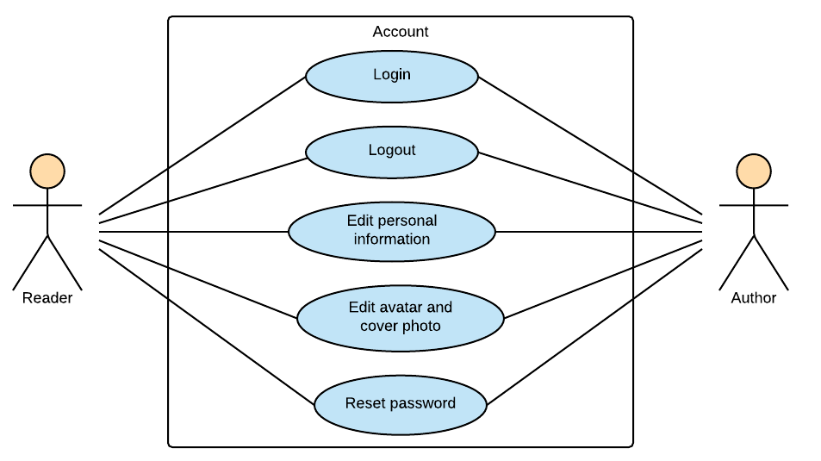

Figure ‑: Reader/Author Module - Account

##### 3.2.2.1.1 UC003-Login

###### 3.2.2.1.1 .1 Use Case Specification - Normal flow

|  |  |  |  |  |
| --- | --- | --- | --- | --- |
| **Use Case ID** | | UC001 | **Version** | 1.0 |
| **Use Case Name** | | Login | | |
| **Created by:** | | HaiCM | **Date Created:** | 09/16/2016 |
| **Primary Actor** | | Registered User | **Secondary Actor** | N/A |
| **Description:** | | This function allows users to login system by registered account. | | |
| **Preconditions:** | | 1. Account must be existed.  2. Display login-register page. | | |
| **Trigger:** | | Click Login button (“Đăng nhập”) | | |
| **Post conditions:** | | 1. Validate account success  2. Display home page as reader or author’s interface. | | |
| **Normal Flow** | | | | |
| **Step** | **Actor** | **Action** | | |
| 1 | User | Enter BSN location on browser | | |
| 2 | BSN | Display login-register page includes:   * Email textbox * Password textbox * Login button: “Đăng nhập” * Forgot password hyperlink: “Bạn quên?” * Account name textbox on register form * Email textbox on register form * Password textbox on register form * Confirm password textbox on register form * Author register hyperlink: “Tác giả đăng ký”   Sign up button: “Đăng ký” | | |
| 3 | User | Enters email and password | | |
| 4 | User | Click “Đăng nhập” button | | |
| 5 | BSN | Logs user into system | | |
| 6 | BSN | Display home page as normal user or author’s interface. | | |
| **Priority** | | High | | |
| **Frequency of Use:** | | High | | |
| **Business Rules:** | |  | | |
| **Other Information:** | | N/A | | |

###### 3.2.2.1.1 .2 Alternative Flows and Exceptions

|  |  |  |  |  |  |  |
| --- | --- | --- | --- | --- | --- | --- |
| **Alternative Flows:** | | | | | | |
| **AT1** | At step 4 in the main flows, if user click other hyperlinks or buttons | | | | | |
| **Step** | **Actor** | | | **Action** | | |
| 4.1 | BSN | | | Redirects user to chosen hyperlink or button | | |
|  | | | | | | |
| **AT2** | | At step 4 in the main flows**,** if BSN failed to validate user name & password | | | | |
| **Step** | | **Actor** | | | **Action** | |
| 4.1 | | BSN | | | Display Login page with message ID#### | |
|  | | | | | | |
| **Exceptions: N/A** | | | | | | |
| **EC1** | | | At step 3 in main flow, if user entered wrong email or password | | | |
| **Step** | | | **Actor** | | | **Action** |
| 3.1 | | | BSN | | | Display Login popup message with ID MSG14 |

##### 3.2.2.1.2 UC004-Logout

|  |  |  |  |  |
| --- | --- | --- | --- | --- |
| **Use Case ID** | |  | **Version** | 1.0 |
| **Use Case Name** | |  | | |
| **Created by:** | |  | **Date Created:** | 09/16/2016 |
| **Primary Actor** | |  | **Secondary Actor** |  |
| **Description:** | | This function allow user to log out system. | | |
| **Preconditions:** | |  | | |
| **Trigger:** | |  | | |
| **Post conditions:** | |  | | |
| **Normal Flow** | | | | |
| **Step** | **Actor** | **Action** | | |
|  |  |  | | |
|  |  |  | | |
| **Alternative Flows:** | | | | |
|  |  | | | |
| **Step** | **Actor** | **Action** | | |
|  |  |  | | |
|  | | | | |
| **Exceptions: N/A** | | | | |
| **Priority** | |  | | |
| **Frequency of Use:** | |  | | |
| **Business Rules:** | |  | | |
| **Other Information:** | |  | | |

###### Alternative Flows and Exceptions

|  |  |  |  |  |
| --- | --- | --- | --- | --- |
| **Alternative Flows:** | | | | |
| **AT1** |  | | | |
| **Step** | **Actor** | | **Action** | |
|  |  | |  | |
|  | | | | |
| **Exceptions: N/A** | | | | |
| **EC1** | |  | | |
| **Step** | | **Actor** | | **Action** |
|  | |  | |  |
|  | |  | |  |
|  | |  | |  |
| **EC2** | |  | | |
| **Step** | | **Actor** | | **Action** |
|  | |  | |  |

##### 3.2.2.1.3 UC005-Edit personal Information

|  |  |  |  |  |
| --- | --- | --- | --- | --- |
| **Use Case ID** | |  | **Version** | 1.0 |
| **Use Case Name** | |  | | |
| **Created by:** | |  | **Date Created:** | 09/16/2016 |
| **Primary Actor** | |  | **Secondary Actor** |  |
| **Description:** | | This function allows users to edit personal information includes name, email, address, date of birth. | | |
| **Preconditions:** | |  | | |
| **Trigger:** | |  | | |
| **Post conditions:** | |  | | |
| **Normal Flow** | | | | |
| **Step** | **Actor** | **Action** | | |
|  |  |  | | |
|  |  |  | | |
| **Alternative Flows:** | | | | |
|  |  | | | |
| **Step** | **Actor** | **Action** | | |
|  |  |  | | |
|  | | | | |
| **Exceptions: N/A** | | | | |
| **Priority** | |  | | |
| **Frequency of Use:** | |  | | |
| **Business Rules:** | |  | | |
| **Other Information:** | |  | | |

###### Alternative Flows and Exceptions

|  |  |  |  |  |
| --- | --- | --- | --- | --- |
| **Alternative Flows:** | | | | |
| **AT1** |  | | | |
| **Step** | **Actor** | | **Action** | |
|  |  | |  | |
|  | | | | |
| **Exceptions: N/A** | | | | |
| **EC1** | |  | | |
| **Step** | | **Actor** | | **Action** |
|  | |  | |  |
|  | |  | |  |
|  | |  | |  |
| **EC2** | |  | | |
| **Step** | | **Actor** | | **Action** |
|  | |  | |  |

##### 3.2.2.1.4 UC006-Edit avatar and cover photo

|  |  |  |  |  |
| --- | --- | --- | --- | --- |
| **Use Case ID** | |  | **Version** | 1.0 |
| **Use Case Name** | |  | | |
| **Created by:** | |  | **Date Created:** | 09/16/2016 |
| **Primary Actor** | |  | **Secondary Actor** |  |
| **Description:** | | This function allows users to edit their avatar and cover photo. | | |
| **Preconditions:** | |  | | |
| **Trigger:** | |  | | |
| **Post conditions:** | |  | | |
| **Normal Flow** | | | | |
| **Step** | **Actor** | **Action** | | |
|  |  |  | | |
|  |  |  | | |
| **Alternative Flows:** | | | | |
|  |  | | | |
| **Step** | **Actor** | **Action** | | |
|  |  |  | | |
|  | | | | |
| **Exceptions: N/A** | | | | |
| **Priority** | |  | | |
| **Frequency of Use:** | |  | | |
| **Business Rules:** | |  | | |
| **Other Information:** | |  | | |

###### Alternative Flows and Exceptions

|  |  |  |  |  |
| --- | --- | --- | --- | --- |
| **Alternative Flows:** | | | | |
| **AT1** |  | | | |
| **Step** | **Actor** | | **Action** | |
|  |  | |  | |
|  | | | | |
| **Exceptions: N/A** | | | | |
| **EC1** | |  | | |
| **Step** | | **Actor** | | **Action** |
|  | |  | |  |
|  | |  | |  |
|  | |  | |  |
| **EC2** | |  | | |
| **Step** | | **Actor** | | **Action** |
|  | |  | |  |

##### 3.2.2.1.5 UC007-Reset password

|  |  |  |  |  |
| --- | --- | --- | --- | --- |
| **Use Case ID** | |  | **Version** | 1.0 |
| **Use Case Name** | |  | | |
| **Created by:** | |  | **Date Created:** | 09/16/2016 |
| **Primary Actor** | |  | **Secondary Actor** |  |
| **Description:** | | This function allows users to reset their password through email. | | |
| **Preconditions:** | |  | | |
| **Trigger:** | |  | | |
| **Post conditions:** | |  | | |
| **Normal Flow** | | | | |
| **Step** | **Actor** | **Action** | | |
|  |  |  | | |
|  |  |  | | |
| **Alternative Flows:** | | | | |
|  |  | | | |
| **Step** | **Actor** | **Action** | | |
|  |  |  | | |
|  | | | | |
| **Exceptions: N/A** | | | | |
| **Priority** | |  | | |
| **Frequency of Use:** | |  | | |
| **Business Rules:** | |  | | |
| **Other Information:** | |  | | |

###### Alternative Flows and Exceptions

|  |  |  |  |  |
| --- | --- | --- | --- | --- |
| **Alternative Flows:** | | | | |
| **AT1** |  | | | |
| **Step** | **Actor** | | **Action** | |
|  |  | |  | |
|  | | | | |
| **Exceptions: N/A** | | | | |
| **EC1** | |  | | |
| **Step** | | **Actor** | | **Action** |
|  | |  | |  |
|  | |  | |  |
|  | |  | |  |
| **EC2** | |  | | |
| **Step** | | **Actor** | | **Action** |
|  | |  | |  |

#### 3.2.2.2 Post

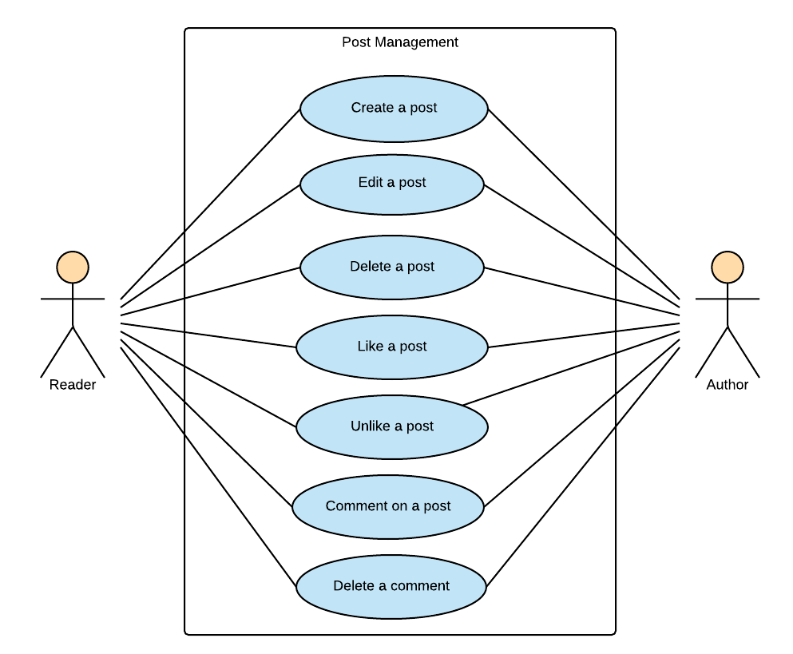

Figure ‑: Reader/Author Module-Post

##### 3.2.2.2.1 UC008-Create a post

|  |  |  |  |  |
| --- | --- | --- | --- | --- |
| **Use Case ID** | |  | **Version** | 1.0 |
| **Use Case Name** | |  | | |
| **Created by:** | |  | **Date Created:** | 10/21/2016 |
| **Primary Actor** | |  | **Secondary Actor** |  |
| **Description:** | | This function allows users to create a post to introduce about books. | | |
| **Preconditions:** | |  | | |
| **Trigger:** | |  | | |
| **Post conditions:** | |  | | |
| **Normal Flow** | | | | |
| **Step** | **Actor** | **Action** | | |
|  |  |  | | |
|  |  |  | | |
| **Alternative Flows:** | | | | |
|  |  | | | |
| **Step** | **Actor** | **Action** | | |
|  |  |  | | |
|  | | | | |
| **Exceptions: N/A** | | | | |
| **Priority** | |  | | |
| **Frequency of Use:** | |  | | |
| **Business Rules:** | |  | | |
| **Other Information:** | |  | | |

###### Alternative Flows and Exceptions

|  |  |  |  |  |
| --- | --- | --- | --- | --- |
| **Alternative Flows:** | | | | |
| **AT1** |  | | | |
| **Step** | **Actor** | | **Action** | |
|  |  | |  | |
|  | | | | |
| **Exceptions: N/A** | | | | |
| **EC1** | |  | | |
| **Step** | | **Actor** | | **Action** |
|  | |  | |  |
|  | |  | |  |
|  | |  | |  |
| **EC2** | |  | | |
| **Step** | | **Actor** | | **Action** |
|  | |  | |  |

##### 3.2.2.2.2 UC009-Edit a post

|  |  |  |  |  |
| --- | --- | --- | --- | --- |
| **Use Case ID** | |  | **Version** | 1.0 |
| **Use Case Name** | |  | | |
| **Created by:** | |  | **Date Created:** | 10/21/2016 |
| **Primary Actor** | |  | **Secondary Actor** |  |
| **Description:** | | This function allows users to edit caption and book tags of a created post. | | |
| **Preconditions:** | |  | | |
| **Trigger:** | |  | | |
| **Post conditions:** | |  | | |
| **Normal Flow** | | | | |
| **Step** | **Actor** | **Action** | | |
|  |  |  | | |
|  |  |  | | |
| **Alternative Flows:** | | | | |
|  |  | | | |
| **Step** | **Actor** | **Action** | | |
|  |  |  | | |
|  | | | | |
| **Exceptions: N/A** | | | | |
| **Priority** | |  | | |
| **Frequency of Use:** | |  | | |
| **Business Rules:** | |  | | |
| **Other Information:** | |  | | |

###### Alternative Flows and Exceptions

|  |  |  |  |  |
| --- | --- | --- | --- | --- |
| **Alternative Flows:** | | | | |
| **AT1** |  | | | |
| **Step** | **Actor** | | **Action** | |
|  |  | |  | |
|  | | | | |
| **Exceptions: N/A** | | | | |
| **EC1** | |  | | |
| **Step** | | **Actor** | | **Action** |
|  | |  | |  |
|  | |  | |  |
|  | |  | |  |
| **EC2** | |  | | |
| **Step** | | **Actor** | | **Action** |
|  | |  | |  |

##### 3.2.2.2.3 UC010-Delete a post

|  |  |  |  |  |
| --- | --- | --- | --- | --- |
| **Use Case ID** | |  | **Version** | 1.0 |
| **Use Case Name** | |  | | |
| **Created by:** | |  | **Date Created:** | 10/21/2016 |
| **Primary Actor** | |  | **Secondary Actor** |  |
| **Description:** | | This function allows user to create a post. | | |
| **Preconditions:** | |  | | |
| **Trigger:** | |  | | |
| **Post conditions:** | |  | | |
| **Normal Flow** | | | | |
| **Step** | **Actor** | **Action** | | |
|  |  |  | | |
|  |  |  | | |
| **Alternative Flows:** | | | | |
|  |  | | | |
| **Step** | **Actor** | **Action** | | |
|  |  |  | | |
|  | | | | |
| **Exceptions: N/A** | | | | |
| **Priority** | |  | | |
| **Frequency of Use:** | |  | | |
| **Business Rules:** | |  | | |
| **Other Information:** | |  | | |

###### Alternative Flows and Exceptions

|  |  |  |  |  |
| --- | --- | --- | --- | --- |
| **Alternative Flows:** | | | | |
| **AT1** |  | | | |
| **Step** | **Actor** | | **Action** | |
|  |  | |  | |
|  | | | | |
| **Exceptions: N/A** | | | | |
| **EC1** | |  | | |
| **Step** | | **Actor** | | **Action** |
|  | |  | |  |
|  | |  | |  |
|  | |  | |  |
| **EC2** | |  | | |
| **Step** | | **Actor** | | **Action** |
|  | |  | |  |

##### 3.2.2.2.4 UC011-Like a post

|  |  |  |  |  |
| --- | --- | --- | --- | --- |
| **Use Case ID** | |  | **Version** | 1.0 |
| **Use Case Name** | |  | | |
| **Created by:** | |  | **Date Created:** | 10/21/2016 |
| **Primary Actor** | |  | **Secondary Actor** |  |
| **Description:** | | This function allows user to like others’ post and their own post. | | |
| **Preconditions:** | |  | | |
| **Trigger:** | |  | | |
| **Post conditions:** | |  | | |
| **Normal Flow** | | | | |
| **Step** | **Actor** | **Action** | | |
|  |  |  | | |
|  |  |  | | |
| **Alternative Flows:** | | | | |
|  |  | | | |
| **Step** | **Actor** | **Action** | | |
|  |  |  | | |
|  | | | | |
| **Exceptions: N/A** | | | | |
| **Priority** | |  | | |
| **Frequency of Use:** | |  | | |
| **Business Rules:** | |  | | |
| **Other Information:** | |  | | |

###### Alternative Flows and Exceptions

|  |  |  |  |  |
| --- | --- | --- | --- | --- |
| **Alternative Flows:** | | | | |
| **AT1** |  | | | |
| **Step** | **Actor** | | **Action** | |
|  |  | |  | |
|  | | | | |
| **Exceptions: N/A** | | | | |
| **EC1** | |  | | |
| **Step** | | **Actor** | | **Action** |
|  | |  | |  |
|  | |  | |  |
|  | |  | |  |
| **EC2** | |  | | |
| **Step** | | **Actor** | | **Action** |
|  | |  | |  |

##### 3.2.2.2.5 UC012-Unlike a post

|  |  |  |  |  |
| --- | --- | --- | --- | --- |
| **Use Case ID** | |  | **Version** | 1.0 |
| **Use Case Name** | |  | | |
| **Created by:** | |  | **Date Created:** | 10/21/2016 |
| **Primary Actor** | |  | **Secondary Actor** |  |
| **Description:** | | This function allows user to unlike others’ post and their own post. | | |
| **Preconditions:** | |  | | |
| **Trigger:** | |  | | |
| **Post conditions:** | |  | | |
| **Normal Flow** | | | | |
| **Step** | **Actor** | **Action** | | |
|  |  |  | | |
|  |  |  | | |
| **Alternative Flows:** | | | | |
|  |  | | | |
| **Step** | **Actor** | **Action** | | |
|  |  |  | | |
|  | | | | |
| **Exceptions: N/A** | | | | |
| **Priority** | |  | | |
| **Frequency of Use:** | |  | | |
| **Business Rules:** | |  | | |
| **Other Information:** | |  | | |

###### Alternative Flows and Exceptions

|  |  |  |  |  |
| --- | --- | --- | --- | --- |
| **Alternative Flows:** | | | | |
| **AT1** |  | | | |
| **Step** | **Actor** | | **Action** | |
|  |  | |  | |
|  | | | | |
| **Exceptions: N/A** | | | | |
| **EC1** | |  | | |
| **Step** | | **Actor** | | **Action** |
|  | |  | |  |
|  | |  | |  |
|  | |  | |  |
| **EC2** | |  | | |
| **Step** | | **Actor** | | **Action** |
|  | |  | |  |

##### 3.2.2.2.6 UC013-Comment on a post

|  |  |  |  |  |
| --- | --- | --- | --- | --- |
| **Use Case ID** | | UC0 | **Version** | 1.0 |
| **Use Case Name** | |  | | |
| **Created by:** | | HuyenPT | **Date Created:** | 10/21/2016 |
| **Primary Actor** | | Reader | **Secondary Actor** | Author |
| **Description:** | |  | | |
| **Preconditions:** | |  | | |
| **Trigger:** | |  | | |
| **Post conditions:** | |  | | |
| **Normal Flow** | | | | |
| **Step** | **Actor** | **Action** | | |
|  |  |  | | |
|  |  |  | | |
| **Alternative Flows:** | | | | |
|  |  | | | |
| **Step** | **Actor** | **Action** | | |
|  |  |  | | |
|  | | | | |
| **Exceptions: N/A** | | | | |
| **Priority** | |  | | |
| **Frequency of Use:** | |  | | |
| **Business Rules:** | |  | | |
| **Other Information:** | |  | | |

###### Alternative Flows and Exceptions

|  |  |  |  |  |
| --- | --- | --- | --- | --- |
| **Alternative Flows:** | | | | |
| **AT1** |  | | | |
| **Step** | **Actor** | | **Action** | |
|  |  | |  | |
|  | | | | |
| **Exceptions: N/A** | | | | |
| **EC1** | |  | | |
| **Step** | | **Actor** | | **Action** |
|  | |  | |  |
|  | |  | |  |
|  | |  | |  |
| **EC2** | |  | | |
| **Step** | | **Actor** | | **Action** |
|  | |  | |  |

##### 3.2.2.2.7 UC014-Delete a comment

|  |  |  |  |  |
| --- | --- | --- | --- | --- |
| **Use Case ID** | | UC0 | **Version** | 1.0 |
| **Use Case Name** | |  | | |
| **Created by:** | | HuyenPT | **Date Created:** | 10/21/2016 |
| **Primary Actor** | | Reader | **Secondary Actor** | Author |
| **Description:** | |  | | |
| **Preconditions:** | |  | | |
| **Trigger:** | |  | | |
| **Post conditions:** | |  | | |
| **Normal Flow** | | | | |
| **Step** | **Actor** | **Action** | | |
|  |  |  | | |
|  |  |  | | |
| **Alternative Flows:** | | | | |
|  |  | | | |
| **Step** | **Actor** | **Action** | | |
|  |  |  | | |
|  | | | | |
| **Exceptions: N/A** | | | | |
| **Priority** | |  | | |
| **Frequency of Use:** | |  | | |
| **Business Rules:** | |  | | |
| **Other Information:** | |  | | |

###### Alternative Flows and Exceptions

|  |  |  |  |  |
| --- | --- | --- | --- | --- |
| **Alternative Flows:** | | | | |
| **AT1** |  | | | |
| **Step** | **Actor** | | **Action** | |
|  |  | |  | |
|  | | | | |
| **Exceptions: N/A** | | | | |
| **EC1** | |  | | |
| **Step** | | **Actor** | | **Action** |
|  | |  | |  |
|  | |  | |  |
|  | |  | |  |
| **EC2** | |  | | |
| **Step** | | **Actor** | | **Action** |
|  | |  | |  |

#### 3.2.2.3 Interaction

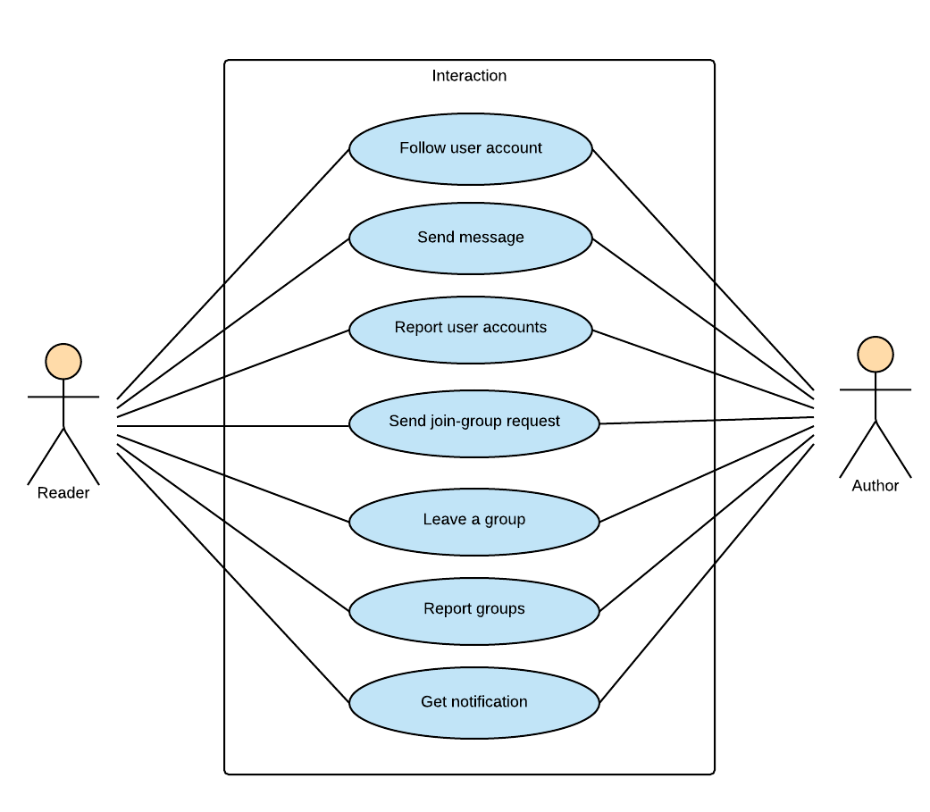

Figure ‑: Reader/Author Module-Interaction

##### 3.2.2.3.1 UC015-Follow user account

|  |  |  |  |  |
| --- | --- | --- | --- | --- |
| **Use Case ID** | | UC0 | **Version** | 1.0 |
| **Use Case Name** | |  | | |
| **Created by:** | | HuyenPT | **Date Created:** | 10/21/2016 |
| **Primary Actor** | | Reader | **Secondary Actor** | Author |
| **Description:** | |  | | |
| **Preconditions:** | |  | | |
| **Trigger:** | |  | | |
| **Post conditions:** | |  | | |
| **Normal Flow** | | | | |
| **Step** | **Actor** | **Action** | | |
|  |  |  | | |
|  |  |  | | |
| **Alternative Flows:** | | | | |
|  |  | | | |
| **Step** | **Actor** | **Action** | | |
|  |  |  | | |
|  | | | | |
| **Exceptions: N/A** | | | | |
| **Priority** | |  | | |
| **Frequency of Use:** | |  | | |
| **Business Rules:** | |  | | |
| **Other Information:** | |  | | |

###### Alternative Flows and Exceptions

|  |  |  |  |  |
| --- | --- | --- | --- | --- |
| **Alternative Flows:** | | | | |
| **AT1** |  | | | |
| **Step** | **Actor** | | **Action** | |
|  |  | |  | |
|  | | | | |
| **Exceptions: N/A** | | | | |
| **EC1** | |  | | |
| **Step** | | **Actor** | | **Action** |
|  | |  | |  |
|  | |  | |  |
|  | |  | |  |
| **EC2** | |  | | |
| **Step** | | **Actor** | | **Action** |
|  | |  | |  |

##### 3.2.2.3.2 UC016-Send message

|  |  |  |  |  |
| --- | --- | --- | --- | --- |
| **Use Case ID** | | UC0 | **Version** | 1.0 |
| **Use Case Name** | |  | | |
| **Created by:** | | HuyenPT | **Date Created:** | 10/21/2016 |
| **Primary Actor** | | Reader | **Secondary Actor** | Author |
| **Description:** | |  | | |
| **Preconditions:** | |  | | |
| **Trigger:** | |  | | |
| **Post conditions:** | |  | | |
| **Normal Flow** | | | | |
| **Step** | **Actor** | **Action** | | |
|  |  |  | | |
|  |  |  | | |
| **Alternative Flows:** | | | | |
|  |  | | | |
| **Step** | **Actor** | **Action** | | |
|  |  |  | | |
|  | | | | |
| **Exceptions: N/A** | | | | |
| **Priority** | |  | | |
| **Frequency of Use:** | |  | | |
| **Business Rules:** | |  | | |
| **Other Information:** | |  | | |

###### Alternative Flows and Exceptions

|  |  |  |  |  |
| --- | --- | --- | --- | --- |
| **Alternative Flows:** | | | | |
| **AT1** |  | | | |
| **Step** | **Actor** | | **Action** | |
|  |  | |  | |
|  | | | | |
| **Exceptions: N/A** | | | | |
| **EC1** | |  | | |
| **Step** | | **Actor** | | **Action** |
|  | |  | |  |
|  | |  | |  |
|  | |  | |  |
| **EC2** | |  | | |
| **Step** | | **Actor** | | **Action** |
|  | |  | |  |

##### 3.2.2.3.3 UC017-Report user account

|  |  |  |  |  |
| --- | --- | --- | --- | --- |
| **Use Case ID** | | UC0 | **Version** | 1.0 |
| **Use Case Name** | |  | | |
| **Created by:** | | HuyenPT | **Date Created:** | 10/21/2016 |
| **Primary Actor** | | Reader | **Secondary Actor** | Author |
| **Description:** | |  | | |
| **Preconditions:** | |  | | |
| **Trigger:** | |  | | |
| **Post conditions:** | |  | | |
| **Normal Flow** | | | | |
| **Step** | **Actor** | **Action** | | |
|  |  |  | | |
|  |  |  | | |
| **Alternative Flows:** | | | | |
|  |  | | | |
| **Step** | **Actor** | **Action** | | |
|  |  |  | | |
|  | | | | |
| **Exceptions: N/A** | | | | |
| **Priority** | |  | | |
| **Frequency of Use:** | |  | | |
| **Business Rules:** | |  | | |
| **Other Information:** | |  | | |

###### Alternative Flows and Exceptions

|  |  |  |  |  |
| --- | --- | --- | --- | --- |
| **Alternative Flows:** | | | | |
| **AT1** |  | | | |
| **Step** | **Actor** | | **Action** | |
|  |  | |  | |
|  | | | | |
| **Exceptions: N/A** | | | | |
| **EC1** | |  | | |
| **Step** | | **Actor** | | **Action** |
|  | |  | |  |
|  | |  | |  |
|  | |  | |  |
| **EC2** | |  | | |
| **Step** | | **Actor** | | **Action** |
|  | |  | |  |

##### 3.2.2.3.4 UC018-Send join-group request

|  |  |  |  |  |
| --- | --- | --- | --- | --- |
| **Use Case ID** | | UC0 | **Version** | 1.0 |
| **Use Case Name** | |  | | |
| **Created by:** | | HuyenPT | **Date Created:** | 10/21/2016 |
| **Primary Actor** | | Reader | **Secondary Actor** | Author |
| **Description:** | |  | | |
| **Preconditions:** | |  | | |
| **Trigger:** | |  | | |
| **Post conditions:** | |  | | |
| **Normal Flow** | | | | |
| **Step** | **Actor** | **Action** | | |
|  |  |  | | |
|  |  |  | | |
| **Alternative Flows:** | | | | |
|  |  | | | |
| **Step** | **Actor** | **Action** | | |
|  |  |  | | |
|  | | | | |
| **Exceptions: N/A** | | | | |
| **Priority** | |  | | |
| **Frequency of Use:** | |  | | |
| **Business Rules:** | |  | | |
| **Other Information:** | |  | | |

###### Alternative Flows and Exceptions

|  |  |  |  |  |
| --- | --- | --- | --- | --- |
| **Alternative Flows:** | | | | |
| **AT1** |  | | | |
| **Step** | **Actor** | | **Action** | |
|  |  | |  | |
|  | | | | |
| **Exceptions: N/A** | | | | |
| **EC1** | |  | | |
| **Step** | | **Actor** | | **Action** |
|  | |  | |  |
|  | |  | |  |
|  | |  | |  |
| **EC2** | |  | | |
| **Step** | | **Actor** | | **Action** |
|  | |  | |  |

##### 3.2.2.3.5 UC019-Leave a group

|  |  |  |  |  |
| --- | --- | --- | --- | --- |
| **Use Case ID** | | UC0 | **Version** | 1.0 |
| **Use Case Name** | |  | | |
| **Created by:** | | HuyenPT | **Date Created:** | 10/21/2016 |
| **Primary Actor** | | Reader | **Secondary Actor** | Author |
| **Description:** | |  | | |
| **Preconditions:** | |  | | |
| **Trigger:** | |  | | |
| **Post conditions:** | |  | | |
| **Normal Flow** | | | | |
| **Step** | **Actor** | **Action** | | |
|  |  |  | | |
|  |  |  | | |
| **Alternative Flows:** | | | | |
|  |  | | | |
| **Step** | **Actor** | **Action** | | |
|  |  |  | | |
|  | | | | |
| **Exceptions: N/A** | | | | |
| **Priority** | |  | | |
| **Frequency of Use:** | |  | | |
| **Business Rules:** | |  | | |
| **Other Information:** | |  | | |

###### Alternative Flows and Exceptions

|  |  |  |  |  |
| --- | --- | --- | --- | --- |
| **Alternative Flows:** | | | | |
| **AT1** |  | | | |
| **Step** | **Actor** | | **Action** | |
|  |  | |  | |
|  | | | | |
| **Exceptions: N/A** | | | | |
| **EC1** | |  | | |
| **Step** | | **Actor** | | **Action** |
|  | |  | |  |
|  | |  | |  |
|  | |  | |  |
| **EC2** | |  | | |
| **Step** | | **Actor** | | **Action** |
|  | |  | |  |

##### 3.2.2.3.6 UC020-Report a group

|  |  |  |  |  |
| --- | --- | --- | --- | --- |
| **Use Case ID** | | UC0 | **Version** | 1.0 |
| **Use Case Name** | |  | | |
| **Created by:** | | HuyenPT | **Date Created:** | 10/21/2016 |
| **Primary Actor** | | Reader | **Secondary Actor** | Author |
| **Description:** | |  | | |
| **Preconditions:** | |  | | |
| **Trigger:** | |  | | |
| **Post conditions:** | |  | | |
| **Normal Flow** | | | | |
| **Step** | **Actor** | **Action** | | |
|  |  |  | | |
|  |  |  | | |
| **Alternative Flows:** | | | | |
|  |  | | | |
| **Step** | **Actor** | **Action** | | |
|  |  |  | | |
|  | | | | |
| **Exceptions: N/A** | | | | |
| **Priority** | |  | | |
| **Frequency of Use:** | |  | | |
| **Business Rules:** | |  | | |
| **Other Information:** | |  | | |

###### Alternative Flows and Exceptions

|  |  |  |  |  |
| --- | --- | --- | --- | --- |
| **Alternative Flows:** | | | | |
| **AT1** |  | | | |
| **Step** | **Actor** | | **Action** | |
|  |  | |  | |
|  | | | | |
| **Exceptions: N/A** | | | | |
| **EC1** | |  | | |
| **Step** | | **Actor** | | **Action** |
|  | |  | |  |
|  | |  | |  |
|  | |  | |  |
| **EC2** | |  | | |
| **Step** | | **Actor** | | **Action** |
|  | |  | |  |

##### 3.2.2.3.7 UC021-Get notification

|  |  |  |  |  |
| --- | --- | --- | --- | --- |
| **Use Case ID** | | UC0 | **Version** | 1.0 |
| **Use Case Name** | |  | | |
| **Created by:** | | HuyenPT | **Date Created:** | 10/21/2016 |
| **Primary Actor** | | Reader | **Secondary Actor** | Author |
| **Description:** | |  | | |
| **Preconditions:** | |  | | |
| **Trigger:** | |  | | |
| **Post conditions:** | |  | | |
| **Normal Flow** | | | | |
| **Step** | **Actor** | **Action** | | |
|  |  |  | | |
|  |  |  | | |
| **Alternative Flows:** | | | | |
|  |  | | | |
| **Step** | **Actor** | **Action** | | |
|  |  |  | | |
|  | | | | |
| **Exceptions: N/A** | | | | |
| **Priority** | |  | | |
| **Frequency of Use:** | |  | | |
| **Business Rules:** | |  | | |
| **Other Information:** | |  | | |

###### Alternative Flows and Exceptions

|  |  |  |  |  |
| --- | --- | --- | --- | --- |
| **Alternative Flows:** | | | | |
| **AT1** |  | | | |
| **Step** | **Actor** | | **Action** | |
|  |  | |  | |
|  | | | | |
| **Exceptions: N/A** | | | | |
| **EC1** | |  | | |
| **Step** | | **Actor** | | **Action** |
|  | |  | |  |
|  | |  | |  |
|  | |  | |  |
| **EC2** | |  | | |
| **Step** | | **Actor** | | **Action** |
|  | |  | |  |

#### 3.2.2.4 Group

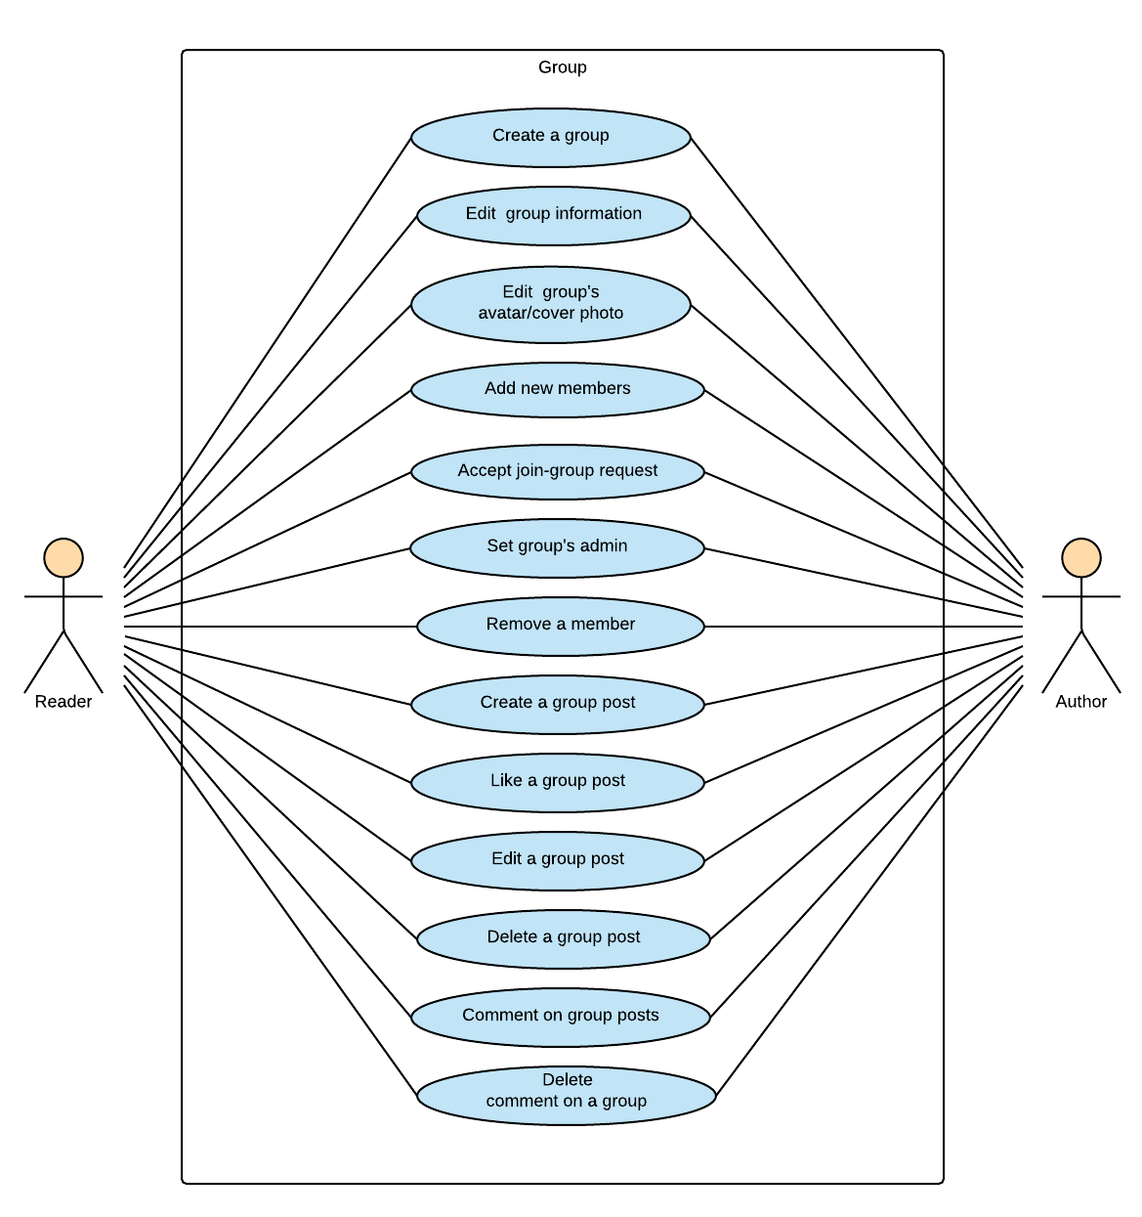

Figure ‑: Reader/Author Module-Group

##### 3.2.2.4.1 UC022-Create a group

|  |  |  |  |  |
| --- | --- | --- | --- | --- |
| **Use Case ID** | | UC0 | **Version** | 1.0 |
| **Use Case Name** | |  | | |
| **Created by:** | | HuyenPT | **Date Created:** | 10/21/2016 |
| **Primary Actor** | | Reader | **Secondary Actor** | Author |
| **Description:** | |  | | |
| **Preconditions:** | |  | | |
| **Trigger:** | |  | | |
| **Post conditions:** | |  | | |
| **Normal Flow** | | | | |
| **Step** | **Actor** | **Action** | | |
|  |  |  | | |
|  |  |  | | |
| **Alternative Flows:** | | | | |
|  |  | | | |
| **Step** | **Actor** | **Action** | | |
|  |  |  | | |
|  | | | | |
| **Exceptions: N/A** | | | | |
| **Priority** | |  | | |
| **Frequency of Use:** | |  | | |
| **Business Rules:** | |  | | |
| **Other Information:** | |  | | |

###### Alternative Flows and Exceptions

|  |  |  |  |  |
| --- | --- | --- | --- | --- |
| **Alternative Flows:** | | | | |
| **AT1** |  | | | |
| **Step** | **Actor** | | **Action** | |
|  |  | |  | |
|  | | | | |
| **Exceptions: N/A** | | | | |
| **EC1** | |  | | |
| **Step** | | **Actor** | | **Action** |
|  | |  | |  |
|  | |  | |  |
|  | |  | |  |
| **EC2** | |  | | |
| **Step** | | **Actor** | | **Action** |
|  | |  | |  |

##### 3.2.2.4.2 UC023-Edit group information

|  |  |  |  |  |
| --- | --- | --- | --- | --- |
| **Use Case ID** | | UC0 | **Version** | 1.0 |
| **Use Case Name** | |  | | |
| **Created by:** | | HuyenPT | **Date Created:** | 10/21/2016 |
| **Primary Actor** | | Reader | **Secondary Actor** | Author |
| **Description:** | |  | | |
| **Preconditions:** | |  | | |
| **Trigger:** | |  | | |
| **Post conditions:** | |  | | |
| **Normal Flow** | | | | |
| **Step** | **Actor** | **Action** | | |
|  |  |  | | |
|  |  |  | | |
| **Alternative Flows:** | | | | |
|  |  | | | |
| **Step** | **Actor** | **Action** | | |
|  |  |  | | |
|  | | | | |
| **Exceptions: N/A** | | | | |
| **Priority** | |  | | |
| **Frequency of Use:** | |  | | |
| **Business Rules:** | |  | | |
| **Other Information:** | |  | | |

###### Alternative Flows and Exceptions

|  |  |  |  |  |
| --- | --- | --- | --- | --- |
| **Alternative Flows:** | | | | |
| **AT1** |  | | | |
| **Step** | **Actor** | | **Action** | |
|  |  | |  | |
|  | | | | |
| **Exceptions: N/A** | | | | |
| **EC1** | |  | | |
| **Step** | | **Actor** | | **Action** |
|  | |  | |  |
|  | |  | |  |
|  | |  | |  |
| **EC2** | |  | | |
| **Step** | | **Actor** | | **Action** |
|  | |  | |  |

##### 3.2.2.4.3 UC024-Edit group’s avatar and cover photo

|  |  |  |  |  |
| --- | --- | --- | --- | --- |
| **Use Case ID** | | UC0 | **Version** | 1.0 |
| **Use Case Name** | |  | | |
| **Created by:** | | HuyenPT | **Date Created:** | 10/21/2016 |
| **Primary Actor** | | Reader | **Secondary Actor** | Author |
| **Description:** | |  | | |
| **Preconditions:** | |  | | |
| **Trigger:** | |  | | |
| **Post conditions:** | |  | | |
| **Normal Flow** | | | | |
| **Step** | **Actor** | **Action** | | |
|  |  |  | | |
|  |  |  | | |
| **Alternative Flows:** | | | | |
|  |  | | | |
| **Step** | **Actor** | **Action** | | |
|  |  |  | | |
|  | | | | |
| **Exceptions: N/A** | | | | |
| **Priority** | |  | | |
| **Frequency of Use:** | |  | | |
| **Business Rules:** | |  | | |
| **Other Information:** | |  | | |

###### Alternative Flows and Exceptions

|  |  |  |  |  |
| --- | --- | --- | --- | --- |
| **Alternative Flows:** | | | | |
| **AT1** |  | | | |
| **Step** | **Actor** | | **Action** | |
|  |  | |  | |
|  | | | | |
| **Exceptions: N/A** | | | | |
| **EC1** | |  | | |
| **Step** | | **Actor** | | **Action** |
|  | |  | |  |
|  | |  | |  |
|  | |  | |  |
| **EC2** | |  | | |
| **Step** | | **Actor** | | **Action** |
|  | |  | |  |

##### 3.2.2.4.4 UC025-Add new member

|  |  |  |  |  |
| --- | --- | --- | --- | --- |
| **Use Case ID** | | UC0 | **Version** | 1.0 |
| **Use Case Name** | |  | | |
| **Created by:** | | HuyenPT | **Date Created:** | 10/21/2016 |
| **Primary Actor** | | Reader | **Secondary Actor** | Author |
| **Description:** | |  | | |
| **Preconditions:** | |  | | |
| **Trigger:** | |  | | |
| **Post conditions:** | |  | | |
| **Normal Flow** | | | | |
| **Step** | **Actor** | **Action** | | |
|  |  |  | | |
|  |  |  | | |
| **Alternative Flows:** | | | | |
|  |  | | | |
| **Step** | **Actor** | **Action** | | |
|  |  |  | | |
|  | | | | |
| **Exceptions: N/A** | | | | |
| **Priority** | |  | | |
| **Frequency of Use:** | |  | | |
| **Business Rules:** | |  | | |
| **Other Information:** | |  | | |

###### Alternative Flows and Exceptions

|  |  |  |  |  |
| --- | --- | --- | --- | --- |
| **Alternative Flows:** | | | | |
| **AT1** |  | | | |
| **Step** | **Actor** | | **Action** | |
|  |  | |  | |
|  | | | | |
| **Exceptions: N/A** | | | | |
| **EC1** | |  | | |
| **Step** | | **Actor** | | **Action** |
|  | |  | |  |
|  | |  | |  |
|  | |  | |  |
| **EC2** | |  | | |
| **Step** | | **Actor** | | **Action** |
|  | |  | |  |

##### 3.2.2.4.5 UC026-Accept join-group request

|  |  |  |  |  |
| --- | --- | --- | --- | --- |
| **Use Case ID** | | UC0 | **Version** | 1.0 |
| **Use Case Name** | |  | | |
| **Created by:** | | HuyenPT | **Date Created:** | 10/21/2016 |
| **Primary Actor** | | Reader | **Secondary Actor** | Author |
| **Description:** | |  | | |
| **Preconditions:** | |  | | |
| **Trigger:** | |  | | |
| **Post conditions:** | |  | | |
| **Normal Flow** | | | | |
| **Step** | **Actor** | **Action** | | |
|  |  |  | | |
|  |  |  | | |
| **Alternative Flows:** | | | | |
|  |  | | | |
| **Step** | **Actor** | **Action** | | |
|  |  |  | | |
|  | | | | |
| **Exceptions: N/A** | | | | |
| **Priority** | |  | | |
| **Frequency of Use:** | |  | | |
| **Business Rules:** | |  | | |
| **Other Information:** | |  | | |

###### Alternative Flows and Exceptions

|  |  |  |  |  |
| --- | --- | --- | --- | --- |
| **Alternative Flows:** | | | | |
| **AT1** |  | | | |
| **Step** | **Actor** | | **Action** | |
|  |  | |  | |
|  | | | | |
| **Exceptions: N/A** | | | | |
| **EC1** | |  | | |
| **Step** | | **Actor** | | **Action** |
|  | |  | |  |
|  | |  | |  |
|  | |  | |  |
| **EC2** | |  | | |
| **Step** | | **Actor** | | **Action** |
|  | |  | |  |

##### 3.2.2.4.6 UC027-Set group’s admin

|  |  |  |  |  |
| --- | --- | --- | --- | --- |
| **Use Case ID** | | UC0 | **Version** | 1.0 |
| **Use Case Name** | |  | | |
| **Created by:** | | HuyenPT | **Date Created:** | 10/21/2016 |
| **Primary Actor** | | Reader | **Secondary Actor** | Author |
| **Description:** | |  | | |
| **Preconditions:** | |  | | |
| **Trigger:** | |  | | |
| **Post conditions:** | |  | | |
| **Normal Flow** | | | | |
| **Step** | **Actor** | **Action** | | |
|  |  |  | | |
|  |  |  | | |
| **Alternative Flows:** | | | | |
|  |  | | | |
| **Step** | **Actor** | **Action** | | |
|  |  |  | | |
|  | | | | |
| **Exceptions: N/A** | | | | |
| **Priority** | |  | | |
| **Frequency of Use:** | |  | | |
| **Business Rules:** | |  | | |
| **Other Information:** | |  | | |

###### Alternative Flows and Exceptions

|  |  |  |  |  |
| --- | --- | --- | --- | --- |
| **Alternative Flows:** | | | | |
| **AT1** |  | | | |
| **Step** | **Actor** | | **Action** | |
|  |  | |  | |
|  | | | | |
| **Exceptions: N/A** | | | | |
| **EC1** | |  | | |
| **Step** | | **Actor** | | **Action** |
|  | |  | |  |
|  | |  | |  |
|  | |  | |  |
| **EC2** | |  | | |
| **Step** | | **Actor** | | **Action** |
|  | |  | |  |

##### 3.2.2.4.7 UC028-Remove a member

|  |  |  |  |  |
| --- | --- | --- | --- | --- |
| **Use Case ID** | | UC0 | **Version** | 1.0 |
| **Use Case Name** | |  | | |
| **Created by:** | | HuyenPT | **Date Created:** | 10/21/2016 |
| **Primary Actor** | | Reader | **Secondary Actor** | Author |
| **Description:** | |  | | |
| **Preconditions:** | |  | | |
| **Trigger:** | |  | | |
| **Post conditions:** | |  | | |
| **Normal Flow** | | | | |
| **Step** | **Actor** | **Action** | | |
|  |  |  | | |
|  |  |  | | |
| **Alternative Flows:** | | | | |
|  |  | | | |
| **Step** | **Actor** | **Action** | | |
|  |  |  | | |
|  | | | | |
| **Exceptions: N/A** | | | | |
| **Priority** | |  | | |
| **Frequency of Use:** | |  | | |
| **Business Rules:** | |  | | |
| **Other Information:** | |  | | |

###### Alternative Flows and Exceptions

|  |  |  |  |  |
| --- | --- | --- | --- | --- |
| **Alternative Flows:** | | | | |
| **AT1** |  | | | |
| **Step** | **Actor** | | **Action** | |
|  |  | |  | |
|  | | | | |
| **Exceptions: N/A** | | | | |
| **EC1** | |  | | |
| **Step** | | **Actor** | | **Action** |
|  | |  | |  |
|  | |  | |  |
|  | |  | |  |
| **EC2** | |  | | |
| **Step** | | **Actor** | | **Action** |
|  | |  | |  |

##### 3.2.2.4.8 UC029-Create group post

|  |  |  |  |  |
| --- | --- | --- | --- | --- |
| **Use Case ID** | | UC0 | **Version** | 1.0 |
| **Use Case Name** | |  | | |
| **Created by:** | | HuyenPT | **Date Created:** | 10/21/2016 |
| **Primary Actor** | | Reader | **Secondary Actor** | Author |
| **Description:** | |  | | |
| **Preconditions:** | |  | | |
| **Trigger:** | |  | | |
| **Post conditions:** | |  | | |
| **Normal Flow** | | | | |
| **Step** | **Actor** | **Action** | | |
|  |  |  | | |
|  |  |  | | |
| **Alternative Flows:** | | | | |
|  |  | | | |
| **Step** | **Actor** | **Action** | | |
|  |  |  | | |
|  | | | | |
| **Exceptions: N/A** | | | | |
| **Priority** | |  | | |
| **Frequency of Use:** | |  | | |
| **Business Rules:** | |  | | |
| **Other Information:** | |  | | |

###### Alternative Flows and Exceptions

|  |  |  |  |  |
| --- | --- | --- | --- | --- |
| **Alternative Flows:** | | | | |
| **AT1** |  | | | |
| **Step** | **Actor** | | **Action** | |
|  |  | |  | |
|  | | | | |
| **Exceptions: N/A** | | | | |
| **EC1** | |  | | |
| **Step** | | **Actor** | | **Action** |
|  | |  | |  |
|  | |  | |  |
|  | |  | |  |
| **EC2** | |  | | |
| **Step** | | **Actor** | | **Action** |
|  | |  | |  |

##### 3.2.2.4.9 UC030-Like a group post

|  |  |  |  |  |
| --- | --- | --- | --- | --- |
| **Use Case ID** | | UC0 | **Version** | 1.0 |
| **Use Case Name** | |  | | |
| **Created by:** | | HuyenPT | **Date Created:** | 10/21/2016 |
| **Primary Actor** | | Reader | **Secondary Actor** | Author |
| **Description:** | |  | | |
| **Preconditions:** | |  | | |
| **Trigger:** | |  | | |
| **Post conditions:** | |  | | |
| **Normal Flow** | | | | |
| **Step** | **Actor** | **Action** | | |
|  |  |  | | |
|  |  |  | | |
| **Alternative Flows:** | | | | |
|  |  | | | |
| **Step** | **Actor** | **Action** | | |
|  |  |  | | |
|  | | | | |
| **Exceptions: N/A** | | | | |
| **Priority** | |  | | |
| **Frequency of Use:** | |  | | |
| **Business Rules:** | |  | | |
| **Other Information:** | |  | | |

###### Alternative Flows and Exceptions

|  |  |  |  |  |
| --- | --- | --- | --- | --- |
| **Alternative Flows:** | | | | |
| **AT1** |  | | | |
| **Step** | **Actor** | | **Action** | |
|  |  | |  | |
|  | | | | |
| **Exceptions: N/A** | | | | |
| **EC1** | |  | | |
| **Step** | | **Actor** | | **Action** |
|  | |  | |  |
|  | |  | |  |
|  | |  | |  |
| **EC2** | |  | | |
| **Step** | | **Actor** | | **Action** |
|  | |  | |  |

##### 3.2.2.4.10 UC031-Edit group post

|  |  |  |  |  |
| --- | --- | --- | --- | --- |
| **Use Case ID** | | UC0 | **Version** | 1.0 |
| **Use Case Name** | |  | | |
| **Created by:** | | HuyenPT | **Date Created:** | 10/21/2016 |
| **Primary Actor** | | Reader | **Secondary Actor** | Author |
| **Description:** | |  | | |
| **Preconditions:** | |  | | |
| **Trigger:** | |  | | |
| **Post conditions:** | |  | | |
| **Normal Flow** | | | | |
| **Step** | **Actor** | **Action** | | |
|  |  |  | | |
|  |  |  | | |
| **Alternative Flows:** | | | | |
|  |  | | | |
| **Step** | **Actor** | **Action** | | |
|  |  |  | | |
|  | | | | |
| **Exceptions: N/A** | | | | |
| **Priority** | |  | | |
| **Frequency of Use:** | |  | | |
| **Business Rules:** | |  | | |
| **Other Information:** | |  | | |

###### Alternative Flows and Exceptions

|  |  |  |  |  |
| --- | --- | --- | --- | --- |
| **Alternative Flows:** | | | | |
| **AT1** |  | | | |
| **Step** | **Actor** | | **Action** | |
|  |  | |  | |
|  | | | | |
| **Exceptions: N/A** | | | | |
| **EC1** | |  | | |
| **Step** | | **Actor** | | **Action** |
|  | |  | |  |
|  | |  | |  |
|  | |  | |  |
| **EC2** | |  | | |
| **Step** | | **Actor** | | **Action** |
|  | |  | |  |

##### 3.2.2.4.11 UC032-Delete group post

|  |  |  |  |  |
| --- | --- | --- | --- | --- |
| **Use Case ID** | | UC0 | **Version** | 1.0 |
| **Use Case Name** | |  | | |
| **Created by:** | | HuyenPT | **Date Created:** | 10/21/2016 |
| **Primary Actor** | | Reader | **Secondary Actor** | Author |
| **Description:** | |  | | |
| **Preconditions:** | |  | | |
| **Trigger:** | |  | | |
| **Post conditions:** | |  | | |
| **Normal Flow** | | | | |
| **Step** | **Actor** | **Action** | | |
|  |  |  | | |
|  |  |  | | |
| **Alternative Flows:** | | | | |
|  |  | | | |
| **Step** | **Actor** | **Action** | | |
|  |  |  | | |
|  | | | | |
| **Exceptions: N/A** | | | | |
| **Priority** | |  | | |
| **Frequency of Use:** | |  | | |
| **Business Rules:** | |  | | |
| **Other Information:** | |  | | |

###### Alternative Flows and Exceptions

|  |  |  |  |  |
| --- | --- | --- | --- | --- |
| **Alternative Flows:** | | | | |
| **AT1** |  | | | |
| **Step** | **Actor** | | **Action** | |
|  |  | |  | |
|  | | | | |
| **Exceptions: N/A** | | | | |
| **EC1** | |  | | |
| **Step** | | **Actor** | | **Action** |
|  | |  | |  |
|  | |  | |  |
|  | |  | |  |
| **EC2** | |  | | |
| **Step** | | **Actor** | | **Action** |
|  | |  | |  |

##### 3.2.2.4.12 UC033-Comment on a group post

|  |  |  |  |  |
| --- | --- | --- | --- | --- |
| **Use Case ID** | | UC0 | **Version** | 1.0 |
| **Use Case Name** | |  | | |
| **Created by:** | | HuyenPT | **Date Created:** | 10/21/2016 |
| **Primary Actor** | | Reader | **Secondary Actor** | Author |
| **Description:** | |  | | |
| **Preconditions:** | |  | | |
| **Trigger:** | |  | | |
| **Post conditions:** | |  | | |
| **Normal Flow** | | | | |
| **Step** | **Actor** | **Action** | | |
|  |  |  | | |
|  |  |  | | |
| **Alternative Flows:** | | | | |
|  |  | | | |
| **Step** | **Actor** | **Action** | | |
|  |  |  | | |
|  | | | | |
| **Exceptions: N/A** | | | | |
| **Priority** | |  | | |
| **Frequency of Use:** | |  | | |
| **Business Rules:** | |  | | |
| **Other Information:** | |  | | |

###### Alternative Flows and Exceptions

|  |  |  |  |  |
| --- | --- | --- | --- | --- |
| **Alternative Flows:** | | | | |
| **AT1** |  | | | |
| **Step** | **Actor** | | **Action** | |
|  |  | |  | |
|  | | | | |
| **Exceptions: N/A** | | | | |
| **EC1** | |  | | |
| **Step** | | **Actor** | | **Action** |
|  | |  | |  |
|  | |  | |  |
|  | |  | |  |
| **EC2** | |  | | |
| **Step** | | **Actor** | | **Action** |
|  | |  | |  |

##### 3.2.2.4.13 UC034-Delete a comment on a group post

|  |  |  |  |  |
| --- | --- | --- | --- | --- |
| **Use Case ID** | | UC0 | **Version** | 1.0 |
| **Use Case Name** | |  | | |
| **Created by:** | | HuyenPT | **Date Created:** | 10/21/2016 |
| **Primary Actor** | | Reader | **Secondary Actor** | Author |
| **Description:** | |  | | |
| **Preconditions:** | |  | | |
| **Trigger:** | |  | | |
| **Post conditions:** | |  | | |
| **Normal Flow** | | | | |
| **Step** | **Actor** | **Action** | | |
|  |  |  | | |
|  |  |  | | |
| **Alternative Flows:** | | | | |
|  |  | | | |
| **Step** | **Actor** | **Action** | | |
|  |  |  | | |
|  | | | | |
| **Exceptions: N/A** | | | | |
| **Priority** | |  | | |
| **Frequency of Use:** | |  | | |
| **Business Rules:** | |  | | |
| **Other Information:** | |  | | |

###### Alternative Flows and Exceptions

|  |  |  |  |  |
| --- | --- | --- | --- | --- |
| **Alternative Flows:** | | | | |
| **AT1** |  | | | |
| **Step** | **Actor** | | **Action** | |
|  |  | |  | |
|  | | | | |
| **Exceptions: N/A** | | | | |
| **EC1** | |  | | |
| **Step** | | **Actor** | | **Action** |
|  | |  | |  |
|  | |  | |  |
|  | |  | |  |
| **EC2** | |  | | |
| **Step** | | **Actor** | | **Action** |
|  | |  | |  |

#### 3.2.2.5 Book

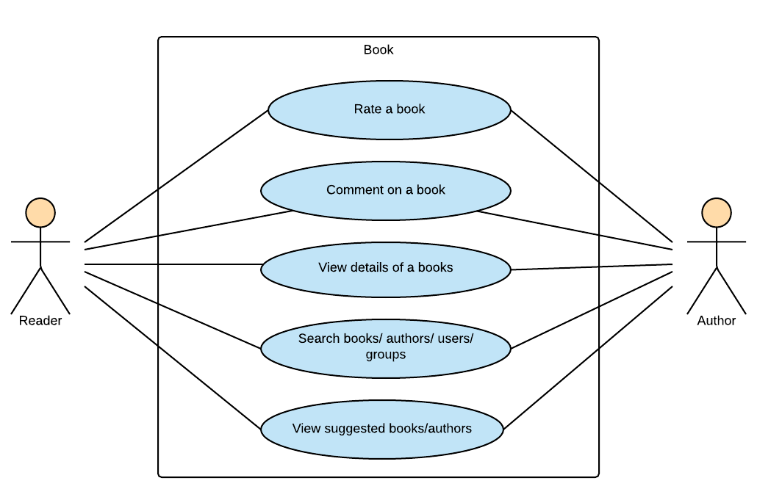

Figure ‑: Reader/Author Module-Book

##### 3.2.2.5.1 UC035-Rate a book

|  |  |  |  |  |
| --- | --- | --- | --- | --- |
| **Use Case ID** | | UC0 | **Version** | 1.0 |
| **Use Case Name** | |  | | |
| **Created by:** | | HuyenPT | **Date Created:** | 10/21/2016 |
| **Primary Actor** | | Reader | **Secondary Actor** | Author |
| **Description:** | |  | | |
| **Preconditions:** | |  | | |
| **Trigger:** | |  | | |
| **Post conditions:** | |  | | |
| **Normal Flow** | | | | |
| **Step** | **Actor** | **Action** | | |
|  |  |  | | |
|  |  |  | | |
| **Alternative Flows:** | | | | |
|  |  | | | |
| **Step** | **Actor** | **Action** | | |
|  |  |  | | |
|  | | | | |
| **Exceptions: N/A** | | | | |
| **Priority** | |  | | |
| **Frequency of Use:** | |  | | |
| **Business Rules:** | |  | | |
| **Other Information:** | |  | | |

###### Alternative Flows and Exceptions

|  |  |  |  |  |
| --- | --- | --- | --- | --- |
| **Alternative Flows:** | | | | |
| **AT1** |  | | | |
| **Step** | **Actor** | | **Action** | |
|  |  | |  | |
|  | | | | |
| **Exceptions: N/A** | | | | |
| **EC1** | |  | | |
| **Step** | | **Actor** | | **Action** |
|  | |  | |  |
|  | |  | |  |
|  | |  | |  |
| **EC2** | |  | | |
| **Step** | | **Actor** | | **Action** |
|  | |  | |  |

##### 3.2.2.5.2 UC036-Comment on a book

|  |  |  |  |  |
| --- | --- | --- | --- | --- |
| **Use Case ID** | | UC0 | **Version** | 1.0 |
| **Use Case Name** | |  | | |
| **Created by:** | | HuyenPT | **Date Created:** | 10/21/2016 |
| **Primary Actor** | | Reader | **Secondary Actor** | Author |
| **Description:** | |  | | |
| **Preconditions:** | |  | | |
| **Trigger:** | |  | | |
| **Post conditions:** | |  | | |
| **Normal Flow** | | | | |
| **Step** | **Actor** | **Action** | | |
|  |  |  | | |
|  |  |  | | |
| **Alternative Flows:** | | | | |
|  |  | | | |
| **Step** | **Actor** | **Action** | | |
|  |  |  | | |
|  | | | | |
| **Exceptions: N/A** | | | | |
| **Priority** | |  | | |
| **Frequency of Use:** | |  | | |
| **Business Rules:** | |  | | |
| **Other Information:** | |  | | |

###### Alternative Flows and Exceptions

|  |  |  |  |  |
| --- | --- | --- | --- | --- |
| **Alternative Flows:** | | | | |
| **AT1** |  | | | |
| **Step** | **Actor** | | **Action** | |
|  |  | |  | |
|  | | | | |
| **Exceptions: N/A** | | | | |
| **EC1** | |  | | |
| **Step** | | **Actor** | | **Action** |
|  | |  | |  |
|  | |  | |  |
|  | |  | |  |
| **EC2** | |  | | |
| **Step** | | **Actor** | | **Action** |
|  | |  | |  |

##### 3.2.2.5.3 UC037-View book’s detail

|  |  |  |  |  |
| --- | --- | --- | --- | --- |
| **Use Case ID** | | UC0 | **Version** | 1.0 |
| **Use Case Name** | |  | | |
| **Created by:** | | HuyenPT | **Date Created:** | 10/21/2016 |
| **Primary Actor** | | Reader | **Secondary Actor** | Author |
| **Description:** | |  | | |
| **Preconditions:** | |  | | |
| **Trigger:** | |  | | |
| **Post conditions:** | |  | | |
| **Normal Flow** | | | | |
| **Step** | **Actor** | **Action** | | |
|  |  |  | | |
|  |  |  | | |
| **Alternative Flows:** | | | | |
|  |  | | | |
| **Step** | **Actor** | **Action** | | |
|  |  |  | | |
|  | | | | |
| **Exceptions: N/A** | | | | |
| **Priority** | |  | | |
| **Frequency of Use:** | |  | | |
| **Business Rules:** | |  | | |
| **Other Information:** | |  | | |

###### Alternative Flows and Exceptions

|  |  |  |  |  |
| --- | --- | --- | --- | --- |
| **Alternative Flows:** | | | | |
| **AT1** |  | | | |
| **Step** | **Actor** | | **Action** | |
|  |  | |  | |
|  | | | | |
| **Exceptions: N/A** | | | | |
| **EC1** | |  | | |
| **Step** | | **Actor** | | **Action** |
|  | |  | |  |
|  | |  | |  |
|  | |  | |  |
| **EC2** | |  | | |
| **Step** | | **Actor** | | **Action** |
|  | |  | |  |

##### 3.2.2.5.4 UC038-Search book/author/other account/group

|  |  |  |  |  |
| --- | --- | --- | --- | --- |
| **Use Case ID** | | UC0 | **Version** | 1.0 |
| **Use Case Name** | |  | | |
| **Created by:** | | HuyenPT | **Date Created:** | 10/21/2016 |
| **Primary Actor** | | Reader | **Secondary Actor** | Author |
| **Description:** | |  | | |
| **Preconditions:** | |  | | |
| **Trigger:** | |  | | |
| **Post conditions:** | |  | | |
| **Normal Flow** | | | | |
| **Step** | **Actor** | **Action** | | |
|  |  |  | | |
|  |  |  | | |
| **Alternative Flows:** | | | | |
|  |  | | | |
| **Step** | **Actor** | **Action** | | |
|  |  |  | | |
|  | | | | |
| **Exceptions: N/A** | | | | |
| **Priority** | |  | | |
| **Frequency of Use:** | |  | | |
| **Business Rules:** | |  | | |
| **Other Information:** | |  | | |

###### Alternative Flows and Exceptions

|  |  |  |  |  |
| --- | --- | --- | --- | --- |
| **Alternative Flows:** | | | | |
| **AT1** |  | | | |
| **Step** | **Actor** | | **Action** | |
|  |  | |  | |
|  | | | | |
| **Exceptions: N/A** | | | | |
| **EC1** | |  | | |
| **Step** | | **Actor** | | **Action** |
|  | |  | |  |
|  | |  | |  |
|  | |  | |  |
| **EC2** | |  | | |
| **Step** | | **Actor** | | **Action** |
|  | |  | |  |

##### 3.2.2.5.5 UC039-View suggested book/author

|  |  |  |  |  |
| --- | --- | --- | --- | --- |
| **Use Case ID** | | UC0 | **Version** | 1.0 |
| **Use Case Name** | |  | | |
| **Created by:** | | HuyenPT | **Date Created:** | 10/21/2016 |
| **Primary Actor** | | Reader | **Secondary Actor** | Author |
| **Description:** | |  | | |
| **Preconditions:** | |  | | |
| **Trigger:** | |  | | |
| **Post conditions:** | |  | | |
| **Normal Flow** | | | | |
| **Step** | **Actor** | **Action** | | |
|  |  |  | | |
|  |  |  | | |
| **Alternative Flows:** | | | | |
|  |  | | | |
| **Step** | **Actor** | **Action** | | |
|  |  |  | | |
|  | | | | |
| **Exceptions: N/A** | | | | |
| **Priority** | |  | | |
| **Frequency of Use:** | |  | | |
| **Business Rules:** | |  | | |
| **Other Information:** | |  | | |

###### Alternative Flows and Exceptions

|  |  |  |  |  |
| --- | --- | --- | --- | --- |
| **Alternative Flows:** | | | | |
| **AT1** |  | | | |
| **Step** | **Actor** | | **Action** | |
|  |  | |  | |
|  | | | | |
| **Exceptions: N/A** | | | | |
| **EC1** | |  | | |
| **Step** | | **Actor** | | **Action** |
|  | |  | |  |
|  | |  | |  |
|  | |  | |  |
| **EC2** | |  | | |
| **Step** | | **Actor** | | **Action** |
|  | |  | |  |

### 3.2.3 Admin Module

#### 3.2.3.1 User Accounts Management

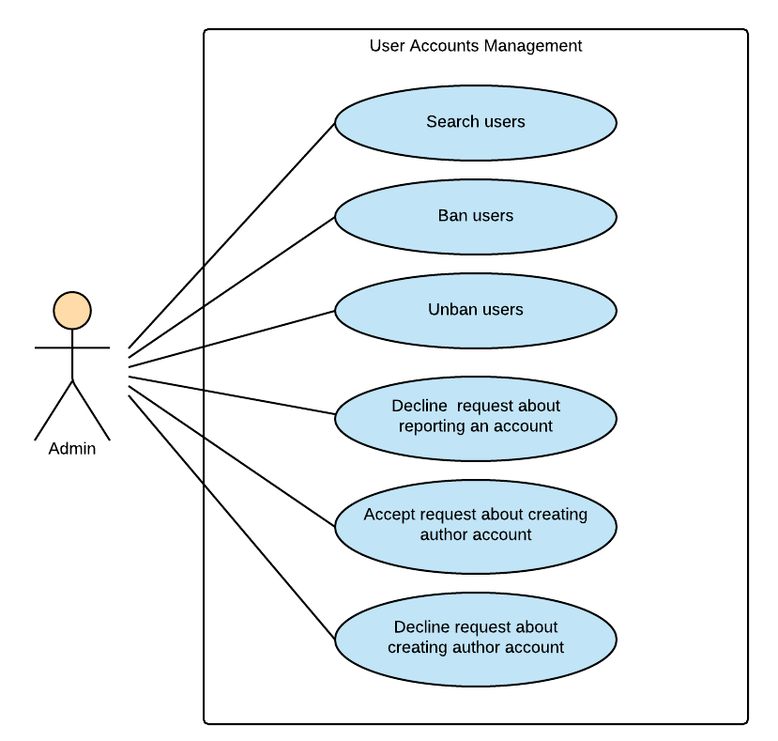

Figure ‑: Admin Module-User Accounts Management

##### 3.2.3.1.1 UC040-Search user

|  |  |  |  |  |
| --- | --- | --- | --- | --- |
| **Use Case ID** | | UC0 | **Version** | 1.0 |
| **Use Case Name** | |  | | |
| **Created by:** | | HuyenPT | **Date Created:** | 10/21/2016 |
| **Primary Actor** | | Admin | **Secondary Actor** | N/A |
| **Description:** | |  | | |
| **Preconditions:** | |  | | |
| **Trigger:** | |  | | |
| **Post conditions:** | |  | | |
| **Normal Flow** | | | | |
| **Step** | **Actor** | **Action** | | |
|  |  |  | | |
|  |  |  | | |
| **Alternative Flows:** | | | | |
|  |  | | | |
| **Step** | **Actor** | **Action** | | |
|  |  |  | | |
|  | | | | |
| **Exceptions: N/A** | | | | |
| **Priority** | |  | | |
| **Frequency of Use:** | |  | | |
| **Business Rules:** | |  | | |
| **Other Information:** | |  | | |

###### Alternative Flows and Exceptions

|  |  |  |  |  |
| --- | --- | --- | --- | --- |
| **Alternative Flows:** | | | | |
| **AT1** |  | | | |
| **Step** | **Actor** | | **Action** | |
|  |  | |  | |
|  | | | | |
| **Exceptions: N/A** | | | | |
| **EC1** | |  | | |
| **Step** | | **Actor** | | **Action** |
|  | |  | |  |
|  | |  | |  |
|  | |  | |  |
| **EC2** | |  | | |
| **Step** | | **Actor** | | **Action** |
|  | |  | |  |

##### 3.2.3.1.2 UC041-Ban user

|  |  |  |  |  |
| --- | --- | --- | --- | --- |
| **Use Case ID** | | UC0 | **Version** | 1.0 |
| **Use Case Name** | |  | | |
| **Created by:** | | HuyenPT | **Date Created:** | 11/25/2016 |
| **Primary Actor** | | Admin | **Secondary Actor** | N/A |
| **Description:** | |  | | |
| **Preconditions:** | |  | | |
| **Trigger:** | |  | | |
| **Post conditions:** | |  | | |
| **Normal Flow** | | | | |
| **Step** | **Actor** | **Action** | | |
|  |  |  | | |
|  |  |  | | |
| **Alternative Flows:** | | | | |
|  |  | | | |
| **Step** | **Actor** | **Action** | | |
|  |  |  | | |
|  | | | | |
| **Exceptions: N/A** | | | | |
| **Priority** | |  | | |
| **Frequency of Use:** | |  | | |
| **Business Rules:** | |  | | |
| **Other Information:** | |  | | |

###### Alternative Flows and Exceptions

|  |  |  |  |  |
| --- | --- | --- | --- | --- |
| **Alternative Flows:** | | | | |
| **AT1** |  | | | |
| **Step** | **Actor** | | **Action** | |
|  |  | |  | |
|  | | | | |
| **Exceptions: N/A** | | | | |
| **EC1** | |  | | |
| **Step** | | **Actor** | | **Action** |
|  | |  | |  |
|  | |  | |  |
|  | |  | |  |
| **EC2** | |  | | |
| **Step** | | **Actor** | | **Action** |
|  | |  | |  |

##### 3.2.3.1.3 UC042-Unban user

|  |  |  |  |  |
| --- | --- | --- | --- | --- |
| **Use Case ID** | | UC0 | **Version** | 1.0 |
| **Use Case Name** | |  | | |
| **Created by:** | | HuyenPT | **Date Created:** | 11/25/2016 |
| **Primary Actor** | | Admin | **Secondary Actor** | N/A |
| **Description:** | |  | | |
| **Preconditions:** | |  | | |
| **Trigger:** | |  | | |
| **Post conditions:** | |  | | |
| **Normal Flow** | | | | |
| **Step** | **Actor** | **Action** | | |
|  |  |  | | |
|  |  |  | | |
| **Alternative Flows:** | | | | |
|  |  | | | |
| **Step** | **Actor** | **Action** | | |
|  |  |  | | |
|  | | | | |
| **Exceptions: N/A** | | | | |
| **Priority** | |  | | |
| **Frequency of Use:** | |  | | |
| **Business Rules:** | |  | | |
| **Other Information:** | |  | | |

###### Alternative Flows and Exceptions

|  |  |  |  |  |
| --- | --- | --- | --- | --- |
| **Alternative Flows:** | | | | |
| **AT1** |  | | | |
| **Step** | **Actor** | | **Action** | |
|  |  | |  | |
|  | | | | |
| **Exceptions: N/A** | | | | |
| **EC1** | |  | | |
| **Step** | | **Actor** | | **Action** |
|  | |  | |  |
|  | |  | |  |
|  | |  | |  |
| **EC2** | |  | | |
| **Step** | | **Actor** | | **Action** |
|  | |  | |  |

##### 3.2.3.1.4 UC043-Decline request reporting an account

|  |  |  |  |  |
| --- | --- | --- | --- | --- |
| **Use Case ID** | | UC0 | **Version** | 1.0 |
| **Use Case Name** | |  | | |
| **Created by:** | | HuyenPT | **Date Created:** | 11/25/2016 |
| **Primary Actor** | | Admin | **Secondary Actor** | N/A |
| **Description:** | |  | | |
| **Preconditions:** | |  | | |
| **Trigger:** | |  | | |
| **Post conditions:** | |  | | |
| **Normal Flow** | | | | |
| **Step** | **Actor** | **Action** | | |
|  |  |  | | |
|  |  |  | | |
| **Alternative Flows:** | | | | |
|  |  | | | |
| **Step** | **Actor** | **Action** | | |
|  |  |  | | |
|  | | | | |
| **Exceptions: N/A** | | | | |
| **Priority** | |  | | |
| **Frequency of Use:** | |  | | |
| **Business Rules:** | |  | | |
| **Other Information:** | |  | | |

###### Alternative Flows and Exceptions

|  |  |  |  |  |
| --- | --- | --- | --- | --- |
| **Alternative Flows:** | | | | |
| **AT1** |  | | | |
| **Step** | **Actor** | | **Action** | |
|  |  | |  | |
|  | | | | |
| **Exceptions: N/A** | | | | |
| **EC1** | |  | | |
| **Step** | | **Actor** | | **Action** |
|  | |  | |  |
|  | |  | |  |
|  | |  | |  |
| **EC2** | |  | | |
| **Step** | | **Actor** | | **Action** |
|  | |  | |  |

##### 3.2.3.1.5 UC044-Accept request creating author account

|  |  |  |  |  |
| --- | --- | --- | --- | --- |
| **Use Case ID** | | UC0 | **Version** | 1.0 |
| **Use Case Name** | |  | | |
| **Created by:** | | HuyenPT | **Date Created:** | 11/25/2016 |
| **Primary Actor** | | Admin | **Secondary Actor** | N/A |
| **Description:** | |  | | |
| **Preconditions:** | |  | | |
| **Trigger:** | |  | | |
| **Post conditions:** | |  | | |
| **Normal Flow** | | | | |
| **Step** | **Actor** | **Action** | | |
|  |  |  | | |
|  |  |  | | |
| **Alternative Flows:** | | | | |
|  |  | | | |
| **Step** | **Actor** | **Action** | | |
|  |  |  | | |
|  | | | | |
| **Exceptions: N/A** | | | | |
| **Priority** | |  | | |
| **Frequency of Use:** | |  | | |
| **Business Rules:** | |  | | |
| **Other Information:** | |  | | |

###### Alternative Flows and Exceptions

|  |  |  |  |  |
| --- | --- | --- | --- | --- |
| **Alternative Flows:** | | | | |
| **AT1** |  | | | |
| **Step** | **Actor** | | **Action** | |
|  |  | |  | |
|  | | | | |
| **Exceptions: N/A** | | | | |
| **EC1** | |  | | |
| **Step** | | **Actor** | | **Action** |
|  | |  | |  |
|  | |  | |  |
|  | |  | |  |
| **EC2** | |  | | |
| **Step** | | **Actor** | | **Action** |
|  | |  | |  |

##### 3.2.3.1.6 UC045-Decline request creating author account

|  |  |  |  |  |
| --- | --- | --- | --- | --- |
| **Use Case ID** | | UC0 | **Version** | 1.0 |
| **Use Case Name** | |  | | |
| **Created by:** | | HuyenPT | **Date Created:** | 11/25/2016 |
| **Primary Actor** | | Admin | **Secondary Actor** | N/A |
| **Description:** | |  | | |
| **Preconditions:** | |  | | |
| **Trigger:** | |  | | |
| **Post conditions:** | |  | | |
| **Normal Flow** | | | | |
| **Step** | **Actor** | **Action** | | |
|  |  |  | | |
|  |  |  | | |
| **Alternative Flows:** | | | | |
|  |  | | | |
| **Step** | **Actor** | **Action** | | |
|  |  |  | | |
|  | | | | |
| **Exceptions: N/A** | | | | |
| **Priority** | |  | | |
| **Frequency of Use:** | |  | | |
| **Business Rules:** | |  | | |
| **Other Information:** | |  | | |

###### Alternative Flows and Exceptions

|  |  |  |  |  |
| --- | --- | --- | --- | --- |
| **Alternative Flows:** | | | | |
| **AT1** |  | | | |
| **Step** | **Actor** | | **Action** | |
|  |  | |  | |
|  | | | | |
| **Exceptions: N/A** | | | | |
| **EC1** | |  | | |
| **Step** | | **Actor** | | **Action** |
|  | |  | |  |
|  | |  | |  |
|  | |  | |  |
| **EC2** | |  | | |
| **Step** | | **Actor** | | **Action** |
|  | |  | |  |

#### 3.2.3.2 Groups Management

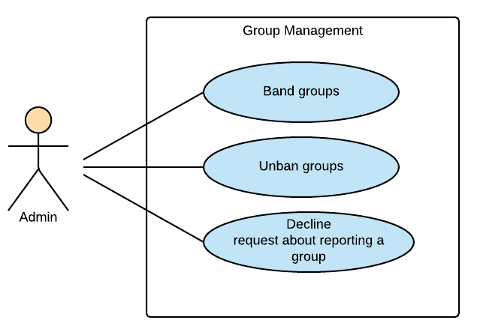

Figure ‑: Admin Module-Group Management

##### 3.2.3.2.1 UC046-Band a group

|  |  |  |  |  |
| --- | --- | --- | --- | --- |
| **Use Case ID** | | UC0 | **Version** | 1.0 |
| **Use Case Name** | |  | | |
| **Created by:** | | HuyenPT | **Date Created:** | 11/25/2016 |
| **Primary Actor** | | Admin | **Secondary Actor** | N/A |
| **Description:** | |  | | |
| **Preconditions:** | |  | | |
| **Trigger:** | |  | | |
| **Post conditions:** | |  | | |
| **Normal Flow** | | | | |
| **Step** | **Actor** | **Action** | | |
|  |  |  | | |
|  |  |  | | |
| **Alternative Flows:** | | | | |
|  |  | | | |
| **Step** | **Actor** | **Action** | | |
|  |  |  | | |
|  | | | | |
| **Exceptions: N/A** | | | | |
| **Priority** | |  | | |
| **Frequency of Use:** | |  | | |
| **Business Rules:** | |  | | |
| **Other Information:** | |  | | |

###### Alternative Flows and Exceptions

|  |  |  |  |  |
| --- | --- | --- | --- | --- |
| **Alternative Flows:** | | | | |
| **AT1** |  | | | |
| **Step** | **Actor** | | **Action** | |
|  |  | |  | |
|  | | | | |
| **Exceptions: N/A** | | | | |
| **EC1** | |  | | |
| **Step** | | **Actor** | | **Action** |
|  | |  | |  |
|  | |  | |  |
|  | |  | |  |
| **EC2** | |  | | |
| **Step** | | **Actor** | | **Action** |
|  | |  | |  |

##### 3.2.3.2.2 UC047-Unban a group

|  |  |  |  |  |
| --- | --- | --- | --- | --- |
| **Use Case ID** | | UC0 | **Version** | 1.0 |
| **Use Case Name** | |  | | |
| **Created by:** | | HuyenPT | **Date Created:** | 11/25/2016 |
| **Primary Actor** | | Admin | **Secondary Actor** | N/A |
| **Description:** | |  | | |
| **Preconditions:** | |  | | |
| **Trigger:** | |  | | |
| **Post conditions:** | |  | | |
| **Normal Flow** | | | | |
| **Step** | **Actor** | **Action** | | |
|  |  |  | | |
|  |  |  | | |
| **Alternative Flows:** | | | | |
|  |  | | | |
| **Step** | **Actor** | **Action** | | |
|  |  |  | | |
|  | | | | |
| **Exceptions: N/A** | | | | |
| **Priority** | |  | | |
| **Frequency of Use:** | |  | | |
| **Business Rules:** | |  | | |
| **Other Information:** | |  | | |

###### Alternative Flows and Exceptions

|  |  |  |  |  |
| --- | --- | --- | --- | --- |
| **Alternative Flows:** | | | | |
| **AT1** |  | | | |
| **Step** | **Actor** | | **Action** | |
|  |  | |  | |
|  | | | | |
| **Exceptions: N/A** | | | | |
| **EC1** | |  | | |
| **Step** | | **Actor** | | **Action** |
|  | |  | |  |
|  | |  | |  |
|  | |  | |  |
| **EC2** | |  | | |
| **Step** | | **Actor** | | **Action** |
|  | |  | |  |

##### 3.2.3.2.3 UC048-Decline request reporting a group

|  |  |  |  |  |
| --- | --- | --- | --- | --- |
| **Use Case ID** | | UC0 | **Version** | 1.0 |
| **Use Case Name** | |  | | |
| **Created by:** | | HuyenPT | **Date Created:** | 11/25/2016 |
| **Primary Actor** | | Admin | **Secondary Actor** | N/A |
| **Description:** | |  | | |
| **Preconditions:** | |  | | |
| **Trigger:** | |  | | |
| **Post conditions:** | |  | | |
| **Normal Flow** | | | | |
| **Step** | **Actor** | **Action** | | |
|  |  |  | | |
|  |  |  | | |
| **Alternative Flows:** | | | | |
|  |  | | | |
| **Step** | **Actor** | **Action** | | |
|  |  |  | | |
|  | | | | |
| **Exceptions: N/A** | | | | |
| **Priority** | |  | | |
| **Frequency of Use:** | |  | | |
| **Business Rules:** | |  | | |
| **Other Information:** | |  | | |

###### Alternative Flows and Exceptions

|  |  |  |  |  |
| --- | --- | --- | --- | --- |
| **Alternative Flows:** | | | | |
| **AT1** |  | | | |
| **Step** | **Actor** | | **Action** | |
|  |  | |  | |
|  | | | | |
| **Exceptions: N/A** | | | | |
| **EC1** | |  | | |
| **Step** | | **Actor** | | **Action** |
|  | |  | |  |
|  | |  | |  |
|  | |  | |  |
| **EC2** | |  | | |
| **Step** | | **Actor** | | **Action** |
|  | |  | |  |

#### 3.2.3.3 Books Management

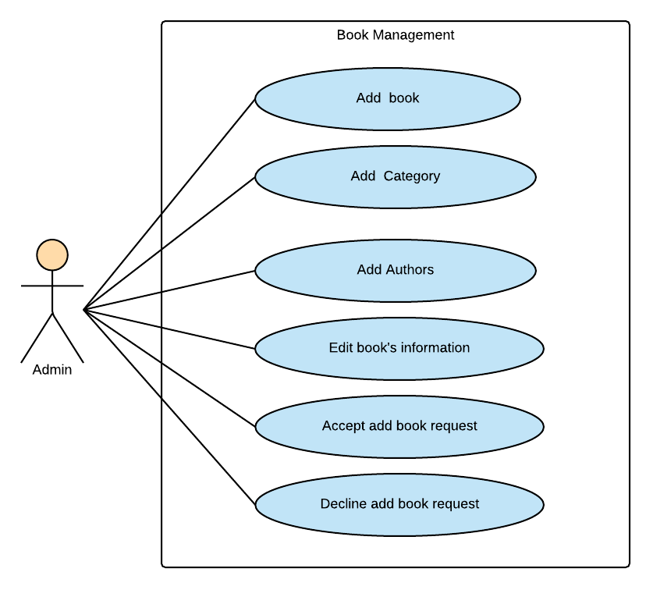

Figure ‑: Admin Module-Book Management

##### 3.2.3.3.1 UC049-Add a new book

|  |  |  |  |  |
| --- | --- | --- | --- | --- |
| **Use Case ID** | | UC0 | **Version** | 1.0 |
| **Use Case Name** | |  | | |
| **Created by:** | | HuyenPT | **Date Created:** | 09/16/2016 |
| **Primary Actor** | | Admin | **Secondary Actor** | N/A |
| **Description:** | |  | | |
| **Preconditions:** | |  | | |
| **Trigger:** | |  | | |
| **Post conditions:** | |  | | |
| **Normal Flow** | | | | |
| **Step** | **Actor** | **Action** | | |
|  |  |  | | |
|  |  |  | | |
| **Alternative Flows:** | | | | |
|  |  | | | |
| **Step** | **Actor** | **Action** | | |
|  |  |  | | |
|  | | | | |
| **Exceptions: N/A** | | | | |
| **Priority** | |  | | |
| **Frequency of Use:** | |  | | |
| **Business Rules:** | |  | | |
| **Other Information:** | |  | | |

###### Alternative Flows and Exceptions

|  |  |  |  |  |
| --- | --- | --- | --- | --- |
| **Alternative Flows:** | | | | |
| **AT1** |  | | | |
| **Step** | **Actor** | | **Action** | |
|  |  | |  | |
|  | | | | |
| **Exceptions: N/A** | | | | |
| **EC1** | |  | | |
| **Step** | | **Actor** | | **Action** |
|  | |  | |  |
|  | |  | |  |
|  | |  | |  |
| **EC2** | |  | | |
| **Step** | | **Actor** | | **Action** |
|  | |  | |  |

##### 3.2.3.3.2 UC050-Add a new category

|  |  |  |  |  |
| --- | --- | --- | --- | --- |
| **Use Case ID** | | UC0 | **Version** | 1.0 |
| **Use Case Name** | |  | | |
| **Created by:** | | HuyenPT | **Date Created:** | 09/16/2016 |
| **Primary Actor** | | Admin | **Secondary Actor** | N/A |
| **Description:** | |  | | |
| **Preconditions:** | |  | | |
| **Trigger:** | |  | | |
| **Post conditions:** | |  | | |
| **Normal Flow** | | | | |
| **Step** | **Actor** | **Action** | | |
|  |  |  | | |
|  |  |  | | |
| **Alternative Flows:** | | | | |
|  |  | | | |
| **Step** | **Actor** | **Action** | | |
|  |  |  | | |
|  | | | | |
| **Exceptions: N/A** | | | | |
| **Priority** | |  | | |
| **Frequency of Use:** | |  | | |
| **Business Rules:** | |  | | |
| **Other Information:** | |  | | |

###### Alternative Flows and Exceptions

|  |  |  |  |  |
| --- | --- | --- | --- | --- |
| **Alternative Flows:** | | | | |
| **AT1** |  | | | |
| **Step** | **Actor** | | **Action** | |
|  |  | |  | |
|  | | | | |
| **Exceptions: N/A** | | | | |
| **EC1** | |  | | |
| **Step** | | **Actor** | | **Action** |
|  | |  | |  |
|  | |  | |  |
|  | |  | |  |
| **EC2** | |  | | |
| **Step** | | **Actor** | | **Action** |
|  | |  | |  |

##### 3.2.3.3.3 UC051-Add an author

|  |  |  |  |  |
| --- | --- | --- | --- | --- |
| **Use Case ID** | | UC0 | **Version** | 1.0 |
| **Use Case Name** | |  | | |
| **Created by:** | | HuyenPT | **Date Created:** | 09/16/2016 |
| **Primary Actor** | | Admin | **Secondary Actor** | N/A |
| **Description:** | |  | | |
| **Preconditions:** | |  | | |
| **Trigger:** | |  | | |
| **Post conditions:** | |  | | |
| **Normal Flow** | | | | |
| **Step** | **Actor** | **Action** | | |
|  |  |  | | |
|  |  |  | | |
| **Alternative Flows:** | | | | |
|  |  | | | |
| **Step** | **Actor** | **Action** | | |
|  |  |  | | |
|  | | | | |
| **Exceptions: N/A** | | | | |
| **Priority** | |  | | |
| **Frequency of Use:** | |  | | |
| **Business Rules:** | |  | | |
| **Other Information:** | |  | | |

###### Alternative Flows and Exceptions

|  |  |  |  |  |
| --- | --- | --- | --- | --- |
| **Alternative Flows:** | | | | |
| **AT1** |  | | | |
| **Step** | **Actor** | | **Action** | |
|  |  | |  | |
|  | | | | |
| **Exceptions: N/A** | | | | |
| **EC1** | |  | | |
| **Step** | | **Actor** | | **Action** |
|  | |  | |  |
|  | |  | |  |
|  | |  | |  |
| **EC2** | |  | | |
| **Step** | | **Actor** | | **Action** |
|  | |  | |  |

##### 3.2.3.3.4 UC052-Edit book's information

|  |  |  |  |  |
| --- | --- | --- | --- | --- |
| **Use Case ID** | | UC0 | **Version** | 1.0 |
| **Use Case Name** | |  | | |
| **Created by:** | | HuyenPT | **Date Created:** | 09/16/2016 |
| **Primary Actor** | | Admin | **Secondary Actor** | N/A |
| **Description:** | |  | | |
| **Preconditions:** | |  | | |
| **Trigger:** | |  | | |
| **Post conditions:** | |  | | |
| **Normal Flow** | | | | |
| **Step** | **Actor** | **Action** | | |
|  |  |  | | |
|  |  |  | | |
| **Alternative Flows:** | | | | |
|  |  | | | |
| **Step** | **Actor** | **Action** | | |
|  |  |  | | |
|  | | | | |
| **Exceptions: N/A** | | | | |
| **Priority** | |  | | |
| **Frequency of Use:** | |  | | |
| **Business Rules:** | |  | | |
| **Other Information:** | |  | | |

###### Alternative Flows and Exceptions

|  |  |  |  |  |
| --- | --- | --- | --- | --- |
| **Alternative Flows:** | | | | |
| **AT1** |  | | | |
| **Step** | **Actor** | | **Action** | |
|  |  | |  | |
|  | | | | |
| **Exceptions: N/A** | | | | |
| **EC1** | |  | | |
| **Step** | | **Actor** | | **Action** |
|  | |  | |  |
|  | |  | |  |
|  | |  | |  |
| **EC2** | |  | | |
| **Step** | | **Actor** | | **Action** |
|  | |  | |  |

##### 3.2.3.3.5 UC053-Accept add-book request

|  |  |  |  |  |
| --- | --- | --- | --- | --- |
| **Use Case ID** | | UC0 | **Version** | 1.0 |
| **Use Case Name** | |  | | |
| **Created by:** | | HuyenPT | **Date Created:** | 09/16/2016 |
| **Primary Actor** | | Admin | **Secondary Actor** | N/A |
| **Description:** | |  | | |
| **Preconditions:** | |  | | |
| **Trigger:** | |  | | |
| **Post conditions:** | |  | | |
| **Normal Flow** | | | | |
| **Step** | **Actor** | **Action** | | |
|  |  |  | | |
|  |  |  | | |
| **Alternative Flows:** | | | | |
|  |  | | | |
| **Step** | **Actor** | **Action** | | |
|  |  |  | | |
|  | | | | |
| **Exceptions: N/A** | | | | |
| **Priority** | |  | | |
| **Frequency of Use:** | |  | | |
| **Business Rules:** | |  | | |
| **Other Information:** | |  | | |

###### Alternative Flows and Exceptions

|  |  |  |  |  |
| --- | --- | --- | --- | --- |
| **Alternative Flows:** | | | | |
| **AT1** |  | | | |
| **Step** | **Actor** | | **Action** | |
|  |  | |  | |
|  | | | | |
| **Exceptions: N/A** | | | | |
| **EC1** | |  | | |
| **Step** | | **Actor** | | **Action** |
|  | |  | |  |
|  | |  | |  |
|  | |  | |  |
| **EC2** | |  | | |
| **Step** | | **Actor** | | **Action** |
|  | |  | |  |

##### 3.2.3.3.6 UC054-Decline add-book request

|  |  |  |  |  |
| --- | --- | --- | --- | --- |
| **Use Case ID** | | UC0 | **Version** | 1.0 |
| **Use Case Name** | |  | | |
| **Created by:** | | HuyenPT | **Date Created:** | 09/16/2016 |
| **Primary Actor** | | Admin | **Secondary Actor** | N/A |
| **Description:** | |  | | |
| **Preconditions:** | |  | | |
| **Trigger:** | |  | | |
| **Post conditions:** | |  | | |
| **Normal Flow** | | | | |
| **Step** | **Actor** | **Action** | | |
|  |  |  | | |
|  |  |  | | |
| **Alternative Flows:** | | | | |
|  |  | | | |
| **Step** | **Actor** | **Action** | | |
|  |  |  | | |
|  | | | | |
| **Exceptions: N/A** | | | | |
| **Priority** | |  | | |
| **Frequency of Use:** | |  | | |
| **Business Rules:** | |  | | |
| **Other Information:** | |  | | |

###### Alternative Flows and Exceptions

|  |  |  |  |  |
| --- | --- | --- | --- | --- |
| **Alternative Flows:** | | | | |
| **AT1** |  | | | |
| **Step** | **Actor** | | **Action** | |
|  |  | |  | |
|  | | | | |
| **Exceptions: N/A** | | | | |
| **EC1** | |  | | |
| **Step** | | **Actor** | | **Action** |
|  | |  | |  |
|  | |  | |  |
|  | |  | |  |
| **EC2** | |  | | |
| **Step** | | **Actor** | | **Action** |
|  | |  | |  |

#### 3.2.3.4 Sliders Management

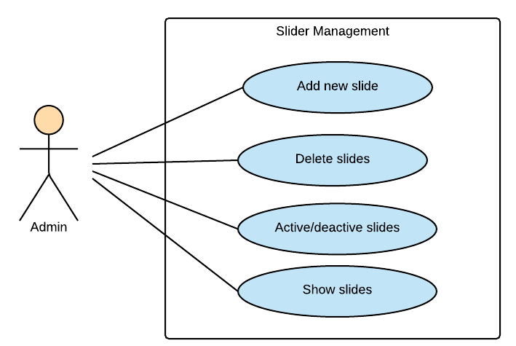

Figure ‑: Admin Module-Slider Management

##### 3.2.3.4.1 UC055-Add a new slider

|  |  |  |  |  |
| --- | --- | --- | --- | --- |
| **Use Case ID** | | UC0 | **Version** | 1.0 |
| **Use Case Name** | |  | | |
| **Created by:** | | HuyenPT | **Date Created:** | 09/16/2016 |
| **Primary Actor** | | Admin | **Secondary Actor** | N/A |
| **Description:** | |  | | |
| **Preconditions:** | |  | | |
| **Trigger:** | |  | | |
| **Post conditions:** | |  | | |
| **Normal Flow** | | | | |
| **Step** | **Actor** | **Action** | | |
|  |  |  | | |
|  |  |  | | |
| **Alternative Flows:** | | | | |
|  |  | | | |
| **Step** | **Actor** | **Action** | | |
|  |  |  | | |
|  | | | | |
| **Exceptions: N/A** | | | | |
| **Priority** | |  | | |
| **Frequency of Use:** | |  | | |
| **Business Rules:** | |  | | |
| **Other Information:** | |  | | |

###### Alternative Flows and Exceptions

|  |  |  |  |  |
| --- | --- | --- | --- | --- |
| **Alternative Flows:** | | | | |
| **AT1** |  | | | |
| **Step** | **Actor** | | **Action** | |
|  |  | |  | |
|  | | | | |
| **Exceptions: N/A** | | | | |
| **EC1** | |  | | |
| **Step** | | **Actor** | | **Action** |
|  | |  | |  |
|  | |  | |  |
|  | |  | |  |
| **EC2** | |  | | |
| **Step** | | **Actor** | | **Action** |
|  | |  | |  |

##### 3.2.3.4.2 UC056-Delete a slider

|  |  |  |  |  |
| --- | --- | --- | --- | --- |
| **Use Case ID** | | UC0 | **Version** | 1.0 |
| **Use Case Name** | |  | | |
| **Created by:** | | HuyenPT | **Date Created:** | 09/16/2016 |
| **Primary Actor** | | Admin | **Secondary Actor** | N/A |
| **Description:** | |  | | |
| **Preconditions:** | |  | | |
| **Trigger:** | |  | | |
| **Post conditions:** | |  | | |
| **Normal Flow** | | | | |
| **Step** | **Actor** | **Action** | | |
|  |  |  | | |
|  |  |  | | |
| **Alternative Flows:** | | | | |
|  |  | | | |
| **Step** | **Actor** | **Action** | | |
|  |  |  | | |
|  | | | | |
| **Exceptions: N/A** | | | | |
| **Priority** | |  | | |
| **Frequency of Use:** | |  | | |
| **Business Rules:** | |  | | |
| **Other Information:** | |  | | |

###### Alternative Flows and Exceptions

|  |  |  |  |  |
| --- | --- | --- | --- | --- |
| **Alternative Flows:** | | | | |
| **AT1** |  | | | |
| **Step** | **Actor** | | **Action** | |
|  |  | |  | |
|  | | | | |
| **Exceptions: N/A** | | | | |
| **EC1** | |  | | |
| **Step** | | **Actor** | | **Action** |
|  | |  | |  |
|  | |  | |  |
|  | |  | |  |
| **EC2** | |  | | |
| **Step** | | **Actor** | | **Action** |
|  | |  | |  |

##### 3.2.3.4.3 UC057-Active/de-active a slider

|  |  |  |  |  |
| --- | --- | --- | --- | --- |
| **Use Case ID** | | UC0 | **Version** | 1.0 |
| **Use Case Name** | |  | | |
| **Created by:** | | HuyenPT | **Date Created:** | 09/16/2016 |
| **Primary Actor** | | Admin | **Secondary Actor** | N/A |
| **Description:** | |  | | |
| **Preconditions:** | |  | | |
| **Trigger:** | |  | | |
| **Post conditions:** | |  | | |
| **Normal Flow** | | | | |
| **Step** | **Actor** | **Action** | | |
|  |  |  | | |
|  |  |  | | |
| **Alternative Flows:** | | | | |
|  |  | | | |
| **Step** | **Actor** | **Action** | | |
|  |  |  | | |
|  | | | | |
| **Exceptions: N/A** | | | | |
| **Priority** | |  | | |
| **Frequency of Use:** | |  | | |
| **Business Rules:** | |  | | |
| **Other Information:** | |  | | |

###### Alternative Flows and Exceptions

|  |  |  |  |  |
| --- | --- | --- | --- | --- |
| **Alternative Flows:** | | | | |
| **AT1** |  | | | |
| **Step** | **Actor** | | **Action** | |
|  |  | |  | |
|  | | | | |
| **Exceptions: N/A** | | | | |
| **EC1** | |  | | |
| **Step** | | **Actor** | | **Action** |
|  | |  | |  |
|  | |  | |  |
|  | |  | |  |
| **EC2** | |  | | |
| **Step** | | **Actor** | | **Action** |
|  | |  | |  |

##### 3.2.3.4.4 UC058-Show a slider

|  |  |  |  |  |
| --- | --- | --- | --- | --- |
| **Use Case ID** | | UC0 | **Version** | 1.0 |
| **Use Case Name** | |  | | |
| **Created by:** | | HuyenPT | **Date Created:** | 09/16/2016 |
| **Primary Actor** | | Admin | **Secondary Actor** | N/A |
| **Description:** | |  | | |
| **Preconditions:** | |  | | |
| **Trigger:** | |  | | |
| **Post conditions:** | |  | | |
| **Normal Flow** | | | | |
| **Step** | **Actor** | **Action** | | |
|  |  |  | | |
|  |  |  | | |
| **Alternative Flows:** | | | | |
|  |  | | | |
| **Step** | **Actor** | **Action** | | |
|  |  |  | | |
|  | | | | |
| **Exceptions: N/A** | | | | |
| **Priority** | |  | | |
| **Frequency of Use:** | |  | | |
| **Business Rules:** | |  | | |
| **Other Information:** | |  | | |

###### Alternative Flows and Exceptions

|  |  |  |  |  |
| --- | --- | --- | --- | --- |
| **Alternative Flows:** | | | | |
| **AT1** |  | | | |
| **Step** | **Actor** | | **Action** | |
|  |  | |  | |
|  | | | | |
| **Exceptions: N/A** | | | | |
| **EC1** | |  | | |
| **Step** | | **Actor** | | **Action** |
|  | |  | |  |
|  | |  | |  |
|  | |  | |  |
| **EC2** | |  | | |
| **Step** | | **Actor** | | **Action** |
|  | |  | |  |

#### 3.2.3.5 Publishers Management

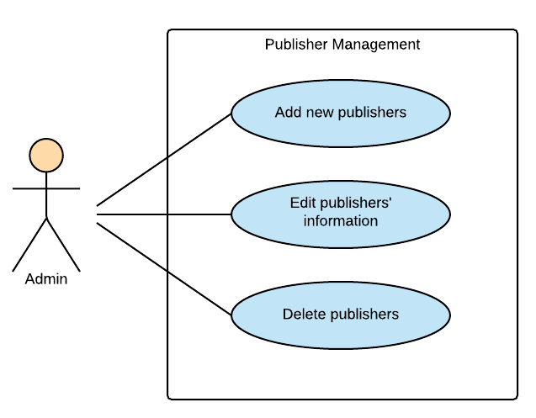

Figure ‑: Admin Module Publisher Management

##### 3.2.3.5.1 UC059-Add a new publisher

|  |  |  |  |  |
| --- | --- | --- | --- | --- |
| **Use Case ID** | | UC0 | **Version** | 1.0 |
| **Use Case Name** | |  | | |
| **Created by:** | | HuyenPT | **Date Created:** | 09/16/2016 |
| **Primary Actor** | | Admin | **Secondary Actor** | N/A |
| **Description:** | |  | | |
| **Preconditions:** | |  | | |
| **Trigger:** | |  | | |
| **Post conditions:** | |  | | |
| **Normal Flow** | | | | |
| **Step** | **Actor** | **Action** | | |
|  |  |  | | |
|  |  |  | | |
| **Alternative Flows:** | | | | |
|  |  | | | |
| **Step** | **Actor** | **Action** | | |
|  |  |  | | |
|  | | | | |
| **Exceptions: N/A** | | | | |
| **Priority** | |  | | |
| **Frequency of Use:** | |  | | |
| **Business Rules:** | |  | | |
| **Other Information:** | |  | | |

###### Alternative Flows and Exceptions

|  |  |  |  |  |
| --- | --- | --- | --- | --- |
| **Alternative Flows:** | | | | |
| **AT1** |  | | | |
| **Step** | **Actor** | | **Action** | |
|  |  | |  | |
|  | | | | |
| **Exceptions: N/A** | | | | |
| **EC1** | |  | | |
| **Step** | | **Actor** | | **Action** |
|  | |  | |  |
|  | |  | |  |
|  | |  | |  |
| **EC2** | |  | | |
| **Step** | | **Actor** | | **Action** |
|  | |  | |  |

##### 3.2.3.5.2 UC060-Edit publisher's information

|  |  |  |  |  |
| --- | --- | --- | --- | --- |
| **Use Case ID** | | UC0 | **Version** | 1.0 |
| **Use Case Name** | |  | | |
| **Created by:** | | HuyenPT | **Date Created:** | 09/16/2016 |
| **Primary Actor** | | Admin | **Secondary Actor** | N/A |
| **Description:** | |  | | |
| **Preconditions:** | |  | | |
| **Trigger:** | |  | | |
| **Post conditions:** | |  | | |
| **Normal Flow** | | | | |
| **Step** | **Actor** | **Action** | | |
|  |  |  | | |
|  |  |  | | |
| **Alternative Flows:** | | | | |
|  |  | | | |
| **Step** | **Actor** | **Action** | | |
|  |  |  | | |
|  | | | | |
| **Exceptions: N/A** | | | | |
| **Priority** | |  | | |
| **Frequency of Use:** | |  | | |
| **Business Rules:** | |  | | |
| **Other Information:** | |  | | |

###### Alternative Flows and Exceptions

|  |  |  |  |  |
| --- | --- | --- | --- | --- |
| **Alternative Flows:** | | | | |
| **AT1** |  | | | |
| **Step** | **Actor** | | **Action** | |
|  |  | |  | |
|  | | | | |
| **Exceptions: N/A** | | | | |
| **EC1** | |  | | |
| **Step** | | **Actor** | | **Action** |
|  | |  | |  |
|  | |  | |  |
|  | |  | |  |
| **EC2** | |  | | |
| **Step** | | **Actor** | | **Action** |
|  | |  | |  |

##### 3.2.3.5.3 UC061-Delete a publisher

|  |  |  |  |  |
| --- | --- | --- | --- | --- |
| **Use Case ID** | | UC0 | **Version** | 1.0 |
| **Use Case Name** | |  | | |
| **Created by:** | | HuyenPT | **Date Created:** | 09/16/2016 |
| **Primary Actor** | | Admin | **Secondary Actor** | N/A |
| **Description:** | |  | | |
| **Preconditions:** | |  | | |
| **Trigger:** | |  | | |
| **Post conditions:** | |  | | |
| **Normal Flow** | | | | |
| **Step** | **Actor** | **Action** | | |
|  |  |  | | |
|  |  |  | | |
| **Alternative Flows:** | | | | |
|  |  | | | |
| **Step** | **Actor** | **Action** | | |
|  |  |  | | |
|  | | | | |
| **Exceptions: N/A** | | | | |
| **Priority** | |  | | |
| **Frequency of Use:** | |  | | |
| **Business Rules:** | |  | | |
| **Other Information:** | |  | | |

###### Alternative Flows and Exceptions

|  |  |  |  |  |
| --- | --- | --- | --- | --- |
| **Alternative Flows:** | | | | |
| **AT1** |  | | | |
| **Step** | **Actor** | | **Action** | |
|  |  | |  | |
|  | | | | |
| **Exceptions: N/A** | | | | |
| **EC1** | |  | | |
| **Step** | | **Actor** | | **Action** |
|  | |  | |  |
|  | |  | |  |
|  | |  | |  |
| **EC2** | |  | | |
| **Step** | | **Actor** | | **Action** |
|  | |  | |  |

#### 3.2.3.6 Statistics

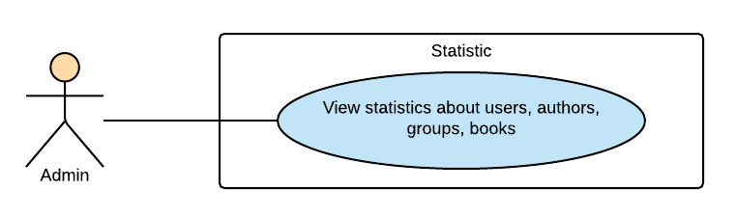

Figure ‑: Admin Module-Statistics

##### 3.2.3.6.1 UC062-View statistic

|  |  |  |  |  |
| --- | --- | --- | --- | --- |
| **Use Case ID** | | UC0 | **Version** | 1.0 |
| **Use Case Name** | |  | | |
| **Created by:** | | HuyenPT | **Date Created:** | 11/25/2016 |
| **Primary Actor** | | Admin | **Secondary Actor** | N/A |
| **Description:** | |  | | |
| **Preconditions:** | |  | | |
| **Trigger:** | |  | | |
| **Post conditions:** | |  | | |
| **Normal Flow** | | | | |
| **Step** | **Actor** | **Action** | | |
|  |  |  | | |
|  |  |  | | |
| **Alternative Flows:** | | | | |
|  |  | | | |
| **Step** | **Actor** | **Action** | | |
|  |  |  | | |
|  | | | | |
| **Exceptions: N/A** | | | | |
| **Priority** | |  | | |
| **Frequency of Use:** | |  | | |
| **Business Rules:** | |  | | |
| **Other Information:** | |  | | |

###### Alternative Flows and Exceptions

|  |  |  |  |  |
| --- | --- | --- | --- | --- |
| **Alternative Flows:** | | | | |
| **AT1** |  | | | |
| **Step** | **Actor** | | **Action** | |
|  |  | |  | |
|  | | | | |
| **Exceptions: N/A** | | | | |
| **EC1** | |  | | |
| **Step** | | **Actor** | | **Action** |
|  | |  | |  |
|  | |  | |  |
|  | |  | |  |
| **EC2** | |  | | |
| **Step** | | **Actor** | | **Action** |
|  | |  | |  |

# NON-FUNCTIONAL SPECIFICATION

## **Reliability**

1. Mean time between failures: The mean time between each failure is expected to be about 480 hours of using.
2. The maximum bugs per function are 2 bugs/a function when user uses software within 2 months. The average number of bugs in the software during system testing is about to be around 1 bugs/KLOC.
3. The database must be backed up daily and can be recovered if necessary

## **Performance Requirements**

### **Availability**

The application must be available 95% of time. Users can access to it everywhere from their Web browser with internet connection.

### **Response time**

In term of response time, waiting time of processing will be 2 to 5 seconds; time to process any functions will not exceed 7 seconds.

### **Maintainability**

* **Coding standards and naming conventions**
  + Output of the project must include coding standards and naming conventions documentations. Implementation code must be easy to maintain.
  + If some components are reused, the documentations of those components must also be included.
* **Design**
  + The design of the system must be loosely coupled that chances on some module will not affect others.
* **Logging**
  + All the errors should be logged, supporting for bug fixing and maintenance.
  + All strange or sensitive situations should also be logged.
* **Mean time to repair:** Immediately when Administrator finds out problem or website is attacked/ hacked by someone. Average 1 day.

### **Usability**

Usability Requirements support the following from the perspective of its primary users:

● **Efficiency of use:** user can complete each function in less than 12 actions

● **Intuitiveness:** User can understand approximately 90% help/ error messages

### **Security Requirements**

In order to avoid unwanted access by strangers, the security implemented in various ways:

1. **User authorize**: Each function must be distributed system access and manipulate the individual parts. To edit information, user must declare their username and password before the operation. Functions will be show after users login dependencies user’s role and permission of each user.
2. **Manage Data Layer**: Only Administrator can modify database system.

### **Hardware/Software Requirements**

● **Hardware requirement:**

**- Server:** Web service 2013, IIS8

**- Client:** PC/Laptop (window 7, window 8, window 10)

● **Software requirements:** Web browser (Chrome 50.0 or higher) with internet connection